

*Draft*

**CONTRACEPTIVE LOGISTICS**

**MANAGEMENT**

**INFORMATION SYSTEM**

User Manual



# Table of Contents

[Table of Contents 3](#_Toc411432051)

[Revision History 7](#_Toc411432052)

[List of Acronyms 8](#_Toc411432053)

[Overview 11](#_Toc411432054)

[Background 11](#_Toc411432055)

[The Paper-based Logistics Management Structure in Pakistan 13](#_Toc411432056)

[Existing Reporting Structure 15](#_Toc411432057)

[Population Welfare Department (PWD) 15](#_Toc411432058)

[Lady Health Workers (LHW) Program 16](#_Toc411432059)

[Department of Health (DOH) 17](#_Toc411432060)

[About Logistics Management Information System 17](#_Toc411432061)

[Assumptions 18](#_Toc411432062)

[System Requirements 18](#_Toc411432063)

[Browser Support 18](#_Toc411432064)

[Users and User Roles 19](#_Toc411432065)

[Users and User Roles 20](#_Toc411432066)

[Anonymous/Guest User 20](#_Toc411432067)

[Authenticated Users 21](#_Toc411432068)

[Store User – District 21](#_Toc411432069)

[Store User – Central 22](#_Toc411432070)

[Step-by-Step 25](#_Toc411432071)

[LMIS Homepage 25](#_Toc411432072)

[Logging into Contraceptive Logistics Management Information System 27](#_Toc411432073)

[Homepage Menu 28](#_Toc411432074)

[Contact Us Tab 28](#_Toc411432075)

[Frequently Asked Questions Tab 28](#_Toc411432076)

[Changing Your Password 30](#_Toc411432077)

[Forgot Password 31](#_Toc411432078)

[Logging Out 32](#_Toc411432079)

[Dashboards 33](#_Toc411432080)

[Introduction 33](#_Toc411432081)

[Public Sector Dashboard 33](#_Toc411432082)

[Stock Out vs Over Stock 35](#_Toc411432083)

[Stock Issued vs Stock on Hand (SOH) in CWH 36](#_Toc411432084)

[Consumption vs Average Monthly Consumption (AMC) 37](#_Toc411432085)

[Couple Year Protection (CYP) 38](#_Toc411432086)

[Couple Year Protection (CYP) Map 39](#_Toc411432087)

[Private Sector Dashboard 40](#_Toc411432088)

[Stock Out vs Over Stock 41](#_Toc411432089)

[Stock Issued vs Stock on Hand (SOH) in CWH 42](#_Toc411432090)

[Consumption vs Average Monthly Consumption (AMC) 43](#_Toc411432091)

[Couple Year Protection (CYP) 44](#_Toc411432092)

[Couple Year Protection (CYP) Map 45](#_Toc411432093)

[Reports 47](#_Toc411432094)

[National Summary Report 48](#_Toc411432095)

[Stakeholder Summary Report 51](#_Toc411432096)

[Provincial Summary Report 53](#_Toc411432097)

[District Summary Report 56](#_Toc411432098)

[District Stock Yearly Report 59](#_Toc411432099)

[Stock Availability Report 60](#_Toc411432100)

[Non/Reported Districts 61](#_Toc411432101)

[Quarterly Reporting Rate 64](#_Toc411432102)

[Provincial Reporting Rate 65](#_Toc411432103)

[Projected Contraceptive Requirements 66](#_Toc411432104)

[Central/Provincial Warehouse Report 67](#_Toc411432105)

[Provincial Yearly Report 68](#_Toc411432106)

[Private Sector Yearly Report 69](#_Toc411432107)

[Public-Private Sector Report 70](#_Toc411432108)

[Maps 71](#_Toc411432109)

[Month of Stock Map 72](#_Toc411432110)

[Consumption Map 73](#_Toc411432111)

[Couple Year Protection Map 74](#_Toc411432112)

[CYP by Population Map 75](#_Toc411432113)

[Reporting Rate Map 76](#_Toc411432114)

[Graphs 77](#_Toc411432115)

[Comparison Graphs 78](#_Toc411432116)

[Simple Graphs 83](#_Toc411432117)

[LMIS Explorer 85](#_Toc411432118)

[Guest User 87](#_Toc411432119)

[Authenticated Users - District 91](#_Toc411432120)

[Dashboard 93](#_Toc411432121)

[Data Entry 93](#_Toc411432122)

[Requisitions (CLR-6) 95](#_Toc411432123)

[New CLR-6 96](#_Toc411432124)

[View CLR-6 97](#_Toc411432125)

[Monthly Reports 99](#_Toc411432126)

[My Reports 100](#_Toc411432127)

[Other Warehouse Reports 102](#_Toc411432128)

[Reports 103](#_Toc411432129)

[Maps 103](#_Toc411432130)

[Graphs 104](#_Toc411432131)

[Authenticated Users - Central 105](#_Toc411432132)

[Dashboard 107](#_Toc411432133)

[Distribution and Stock on Hand (SOH) 107](#_Toc411432134)

[Expiry Status 108](#_Toc411432135)

[Product Summary 110](#_Toc411432136)

[Month of Stock 111](#_Toc411432137)

[Requisitions 113](#_Toc411432138)

[Requisition Requests (CLR-6) 113](#_Toc411432139)

[Inventory Management 117](#_Toc411432140)

[Stock Receive (Supplier) 119](#_Toc411432141)

[Stock Receive (Warehouse) 121](#_Toc411432142)

[Stock Receive Search 122](#_Toc411432143)

[Stock Issue 124](#_Toc411432144)

[Stock Issue Search 125](#_Toc411432145)

[Batch Management 127](#_Toc411432146)

[New Adjustments 130](#_Toc411432147)

[Search Adjustments 131](#_Toc411432148)

[Placement Locations 132](#_Toc411432149)

[Stock Pick 133](#_Toc411432150)

[Location Status 134](#_Toc411432151)

[Gate Pass 136](#_Toc411432152)

[New Gate Pass 137](#_Toc411432153)

[View Gate Pass 138](#_Toc411432154)

[Reports 139](#_Toc411432155)

[Maps 139](#_Toc411432156)

[Graphs 140](#_Toc411432157)

# Revision History

|  |  |  |  |
| --- | --- | --- | --- |
| **Name** | **Date** | **Reason For Changes** | **Version** |
| Pakistan Field Office | December 2013 | First Draft | 1.0 |
| Pakistan Field Office | March 2014 | Additions to Inventory Module | 1.1 |
| Pakistan Field Office | May 2014 | Addition of CLR-6 Requirements | 1.2 |
| Pakistan Field Office | August 2014 | Additions of R-2 enhancements | 2.0 |
| Pakistan Field Office | September 2014 | Additions to Dashboards | 2.1 |
| Pakistan Field Office | March 2015 | Removing of PWD specific details | 2.2 |

# List of Acronyms

|  |  |
| --- | --- |
| AJK | Azad Jammu and Kashmir |
| CWH | Central Warehouse |
| CYP | Couple Years of Protection |
| DDP | District Distribution Points |
| DOH | Department of Health |
| DPIU | District Project Implementation Unit |
| DPWO | District Population Welfare Office |
| FATA | Federally Administered Tribal Areas |
| FLCF | Fist Level Care Facility |
| FWC | Family Welfare Center |
| HIV | Human Immunodeficiency Virus |
| LHW | Lady Health Worker |
| LMIS | Logistics Management Information System |
| MOH | Ministry of Health |
| MOPW | Ministry of Population Welfare |
| MSU | Mobile Service Unit |
| PLDO | Provincial Line Department Outlets |
| PPIU | Provincial Project Implementation Unit |
| RHS-A | Reproductive Health Services – A |
| RHS-B | Reproductive Health Services – B |
| RMP | Registered Medical Practitioners |
| SDP | Service Delivery Point |
| TB | Tuberculosis |
| TBA | Traditional Birth Attendants |
| USAID | United Stated Agency for International Development |
| WMS | Warehouse Management System |

|  |  |
| --- | --- |
| Overview | **1** |
| With Contraceptive Logistics Management Information System | |

This *User Guide* provides step-by-step instructions which help you get started with Logistics Management Information System (LMIS). It provides guidelines on application features to manage logistics data. This user guide is organized according to the logical flow of LMIS features and describes tasks in the same order you can use while working with the application.

|  |  |
| --- | --- |
| *C:\Users\isbah.zulfiqar\Desktop\1382615592_file_edit.png* | **Before You Begin...**  It is recommended to have a working internet connection for web-access to the application in order to review the application side-by-side when reading this manual. |

## Background

USAID | DELIVER PROJECT Pakistan has been tasked by the Government of Pakistan with implementing a Logistics Management Information System (LMIS) using a web-based approach. After several months of thorough consultations with all stakeholders from the public and private sectors, the Project adapted and enhanced the web-based application from the Bangladesh model. During enhancement process, LMIS was contextualized to local stakeholder structure and devolution.

The LMIS was launched by Prime Minister of Pakistan on July 2011 as public sector’s first Logistics Management Information System.

LMIS has the flexibility to integrate other health commodities in addition to contraceptives. The Project has integrated other health products to meet the provincial integrated commodity management requirements. In addition to public sector, application is also able to record contraceptives national sales data of private sector. Currently, the system is able to respond to district level reporting by aggregating facility level data through paper-based reports. In Release-2, LMIS has been enhanced for facility level reporting on logistics indicators for each district along-with district store commodities status. To strengthen reporting and visibility of private sector contraceptives, district level interface has been incorporated in LMIS which will enable provincial and regional health and population departments to see the contribution of private sector in their respective geographical areas.

For nationwide implementation of LMIS, the Project needed to train the expected users of the system. The prescribed training provides knowledge and skills required to enter data into web-based LMIS. LMIS played a significant role in improving stock monitoring at the district and sub-district level.

Central Warehouse (CWH) is a national repository for contraceptive commodities. All public sector stakeholders at the district level raise integrated requisition requests to the CWH for contraceptive supplies. The Project is providing the transportation support from CWH to the district stores.

Timely and accurate data entry and submission of a monthly report at the district level is critical to the functioning of the LMIS. The data collected from the LMIS can then subsequently be used at each level of the supply chain to enhance informed decision making to meet service delivery demands. Utilization of the LMIS depends on the level of understanding of those trained on its various functionalities.

As the Project aims to scale-up LMIS to sub-district level, capacity of all those required to operate LMIS will need to be built. The Project needs to identify the right individuals from the public sector in order to ensure sustainability and accuracy of LMIS data.

## The Paper-based Logistics Management Structure in Pakistan

There are different vertical programs in public health with varying commodity distribution systems for products such as lab equipment, anti-TB drugs and other essential medicines in addition to contraceptives. The verticality of the health system poses a unique challenge in Pakistan. Another complexity includes the fact that some systems are operating under a pull system whereas others are referred to a push system to deliver products. Some programs distribute directly from the central warehouse to the district stores such as for contraceptive while others flow through different supply chain levels. There are linkages among various stakeholders at national, provincial and district levels for requisition, delivery and storage of contraceptives. Any LMIS intended to provide national level stock status and consumption data must accommodate all stakeholders and their linkages.

At the public sector level, there are three main stakeholders; Ministry of National Health Services, Regulations and Coordination (MoNHSR&C), Population Welfare Departments in each province and region and Departments or Directorates of Health in each province and region. Mainly, there are three primary health care components of DOH which includes; Static Health Facilities, Lady Heath Workers (LHW) program and Mother & Neo-natal Child Healthcare (MNCH) program.

A key stakeholder within DOH is National Program for Family Planning and Primary Health Care which is a vertical program implanted through eight provincial project implementation unit (PPIUs) and district project implementation units (DPIU) at the district level. Although there are vertical programs in DOH at the provincial levels, these programs are functionally integrated at the district level. However, a reasonably good coordination exists between Health and Population Welfare Departments.

## Existing Reporting Structure

### Population Welfare Department (PWD)

Figure-1 below illustrates the reporting structure of PWD. All Service Delivery Points (SDPs) report to their respective district/area/agency and the DPWO compiles as well as sends the CLR-15 report to provincial/regional headquarters. Each Provincial/Regional Headquarter and ICT prepares the CLR-11, which is then sent to the Federal office for preparation of the monthly contraceptive performance report. The CWH in Karachi sends the CLR-8 monthly for review at the federal level. The CLR-8 provides stock status of commodities lying in CWH.

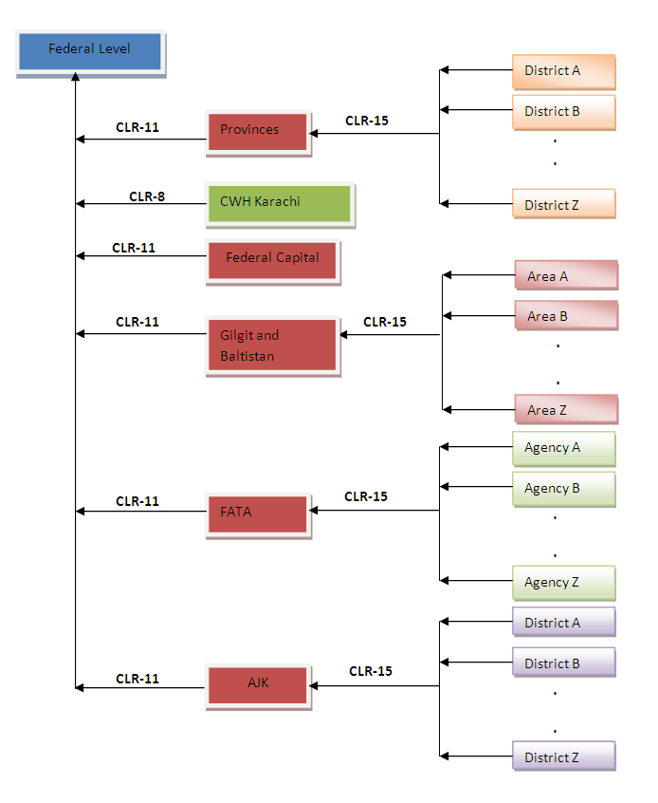

**Figure-1**: A Flowchart showing flow of data from district to federal level in Population Welfare Department.

The following facilities are being managed by district population welfare department which provides contraceptives and supervises activities of following service delivery points:

1. FHC (Family Health Clinic) / RHS-A (Reproductive Health Services – A)
2. FWC (Family Welfare Center)
3. RHS-B (Reproductive Health Services – B)
4. MSU (Mobile Service Unit)
5. Social Mobilizers
6. PLDs (Provincial Line Department Outlets)
7. RMPs (Registered Medical Practitioners)
8. Hakeems (Traditional healers using mostly herbal remedies)
9. Homeopaths
10. DDPs (District Distribution Points)
11. TBA (Traditional Birth Attendants)
12. Counters

### Lady Health Workers (LHW) Program

The LHW program has eight (8) regions called Provincial Project Implementation Units (PPIU) and at the district level, it has District Project Implementation Units (DPIU). The DPIU is responsible for providing contraceptives to LHWs.

The eight Provincial Project Implementation Units are:

1. Peshawar (for Khyber Pakhtunkhwa)
2. FATA secretariat (based in Peshawar, providing services to FATA)
3. Lahore (for Punjab)
4. Hyderabad (for Sindh)
5. Quetta (for Baluchistan)
6. Muzaffarabad (for AJK)
7. Gilgit (for Gilgit and Baltistan)
8. Islamabad (for federal capital territory)

### Department of Health (DOH)

The Department of Health currently receives all supplies from CWH. The district DOH store provides contraceptives to static health facilities and reports family planning data through District Health Information System (DHIS) on a monthly basis.

# About Logistics Management Information System

The draft 2010 population policy clearly emphasizes the importance of operationally effective logistics management information system (LMIS). Paper-based logistics information system was unable to accurately track the contraceptive stock status at various levels of the supply chain from CWH to the facility level. Inaccurate reporting data results in unrealistic forecasting and procurement inefficiencies when trying to work within an entire logistics system. In identifying the need for accurate essential logistics data for decision making, Ministry of National Health Services, Regulations and Coordination (MoNHSR&C) requested the Project to replace the paper-based system to ensure an effective contraceptive supply chain.

The USAID | DELIVER PROJECT is providing technical assistance to MoNHSR&C to strengthen the logistics system and improve overall supply chain management. During the years 2008-2009, a series of consultative meetings were held between the Ministry and USAID | DELIVER PROJECT to access the requirements of the MoNHSR&C. One of the most important areas which require immediate attention is improved data visibility to ensure improved product availability.

## Assumptions

This user guide assumes that you already have Contraceptive Logistics Management Information System accounts as per your geographical level and role. This user guide also assumes that you are familiar with basic web-application account login procedures.

## System Requirements

The Contraceptive Logistics Management Information System is accessible from any Desktop PC, Mac, or Linux computer with Internet access and a supported Web-browser.

## Browser Support

The following browsers and later versions fully support cLMIS standard view:

* Mozilla Firefox (Windows, Mac, Linux)
* Google Chrome (Windows, Mac, Linux)
* Netscape (Windows, Mac, Linux)
* Safari (Mac)
* Internet Explorer 9 and above (Windows)

|  |  |
| --- | --- |
| Users and User Roles | **2** |
| of Logistics Management Information System for Contraceptives | |

This chapter explains the overview and user roles of Logistics Management Information System. The web-based application results in an LMIS system contextualized to fit local stakeholder structure and the devolution of health and population programs to provincial governments. The system brings in district-level reporting by aggregating facility-level data through paper-based reports. With a unified system for reporting and requisitioning, the LMIS system is able to integrate information from all levels and sectors. The web-based LMIS can be accessed at <http://lmis.gov.pk>.

In order to log on to the system, the user will be allocated a username and password. Once successfully logged in, the user will be directed to a ‘user information’ page specific to the organization. This page will contain specific information about the user’s department or organization.

In order to obtain LMIS data and reports, the user must successfully login with his/her username and password. System users are defined by relevant stakeholders and the level in the supply chain they represent. For example, Population Welfare Department users work under Provincial PWD and District Population Welfare Officer. Similarly for the Lady Health Workers’ program, the users are authorized personnel from District Program Implementation Unit (DPIU) and Provincial Program Implementation Unit (PPIU). The following table includes the activities that various users will be able to perform once they login:

*Stakeholder and level specific activities users can perform in cLMIS.*

|  |  |  |  |
| --- | --- | --- | --- |
| **Activity** | **Level** | | |
| **Central** | **District** | **Guest** |
| Data Entry |  |  |  |
| Requisitions |  |  |  |
| Inventory Management |  |  |  |
| Reports |  |  |  |
| Graphs |  |  |  |
| Maps |  |  |  |

*\* The Central warehouse will be responsible for entering all central level stock status updates into the LMIS.*

# User Roles

The Contraceptive Logistics Management Information System Users are basically store operators that manage and record the inventory and stock transactions. Each geographical level entails different user roles associated with their warehouse/store operations.

## Anonymous/Guest User

The Anonymous or Guest user can be any web user with the following capabilities:

|  |  |
| --- | --- |
| **Feature** | **Responsibilities** |
| **Dashboard** | View public sector and private sector dashboards from here. |
| **LMIS Explorer** | View Monthly Store/Facility Report using LMIS explorer. |
| **Reports** | View geographical and periodic logistics information in tabular formats. |
| **Maps** | View geographical and periodic logistics information on the map. |
| **Graphs** | View geographical and periodic logistics information in graphical formats. |

## Authenticated Users

The Authenticated users can log in to cLMIS and perform assigned functions. Each user is assigned responsibilities based on the role and geographical level.

### Store User – District

|  |  |
| --- | --- |
| **Feature** | **Responsibilities** |
| **Dashboard** | View public sector and private sector dashboards from here. |
| **Requisitions** | Add new requisition requests.  View requisition requests. |
| **Data Entry** | Enter new data in stock report.  View stock report for previous month. |
| **Monthly Reports** | View monthly report of the district.  View monthly reports of other districts. |
| **Reports** | View geographical and periodic logistics information in tabular formats. |
| **Maps** | View geographical and periodic logistics information on the map. |
| **Graphs** | View geographical and periodic logistics information in graphical formats. |
| **Others** | Change account password. |

### Store User – Central

|  |  |
| --- | --- |
| **Feature** | **Responsibilities** |
| **Dashboard** | View Distribution and SOH, Expiry Status, Product Summary and Month of Stock dashboards from here. |
| **Inventory Management** | Receive stock from other provincial warehouses.  Receive stock from supplier and create placement vouchers.  Search for received stock.  Issue stock to other warehouses. (Province, Division, District stores) and  create pick order forms.  Search for issued stock.  Manage Batches.  Add placement locations for stock.  Transfer stock to other locations. |
| **Stock Adjustments** | Manage adjustments.  Add adjustments.  Search for adjustments. |
| **Requisitions** | View pending requisition requests.  Approve or deny requisition requests. |
| **Data Entry** | Enter new data in stock report.  View stock report for previous month. |
| **Gate Pass** | Issue a new gate pass.  View the list of issued gate passes. |
| **Monthly Reports** | View monthly report of the central warehouse.  View monthly reports of other districts. |
| **Reports** | View geographical and periodic logistics information in tabular formats. |
| **Maps** | View geographical and periodic logistics information on the map. |
| **Graphs** | View geographical and periodic logistics information in graphical formats. |
| **Others** | Change account password. |

|  |  |
| --- | --- |
| Step-by-Step | **3** |
| Process to using Contraceptive Logistics Management Information System | |

This chapter explains the step-by-step instructions on getting started with cLMIS. In this section, you will learn about:

1. The Contraceptive Logistics Management Information System User Interface.
2. Logging Into Contraceptive Logistics Management Information System.
3. Changing your account password.
4. What to do if you forget your password.
5. Logging Out of Contraceptive Logistics Management Information System.

## LMIS Homepage

The Logistics Management Information System has a single landing page for its three modules for Contraceptives, TB, and Vaccines Management Information System. Enter the URL <http://lmis.gov.pk> to access the application homepage.

Once the user enters the URL <http://lmis.gov.pk>, a user interface (homepage) will appear. The homepage displays a basic introduction to the ‘Pakistan LMIS’.

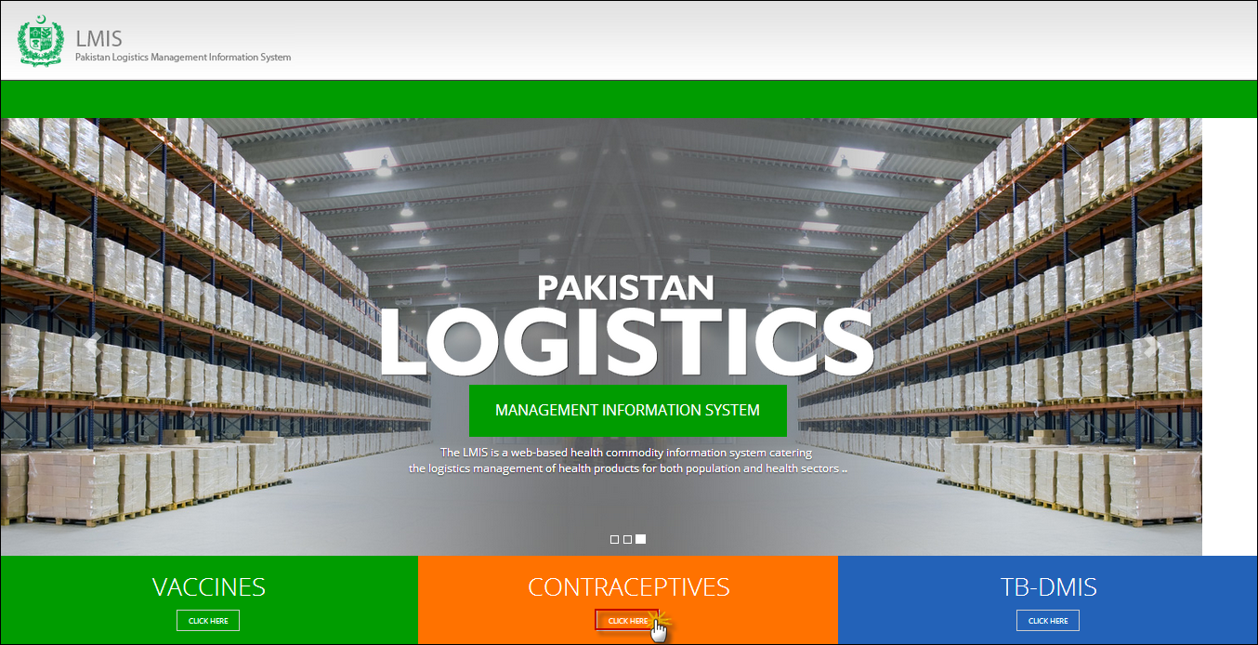

|  |  |
| --- | --- |
| *C:\Users\isbah.zulfiqar\Desktop\1382615592_file_edit.png* | **Before You Begin...**  It is recommended to use cLMIS with Google or Mozilla Fire Fox. Older generations of browsers are also supported; however, their use can lead to issues with on-screen formatting and display. |

Once you click **Contraceptives**, homepage for cLMIS will display.

## Logging into Contraceptive Logistics Management Information System

The cLMIS is a web-based reporting and inventory management application that makes it simple for beginners and experienced users to report inventory data, view performance and graphical reports as well as maps.

Users can also access contraceptive LMIS application directly by using <http://c.lmis.gov.pk> URL. Once the user enters the URL <http://c.lmis.gov.pk>, a user interface (homepage) will appear. The homepage displays a basic introduction to the ‘contraceptive LMIS’.

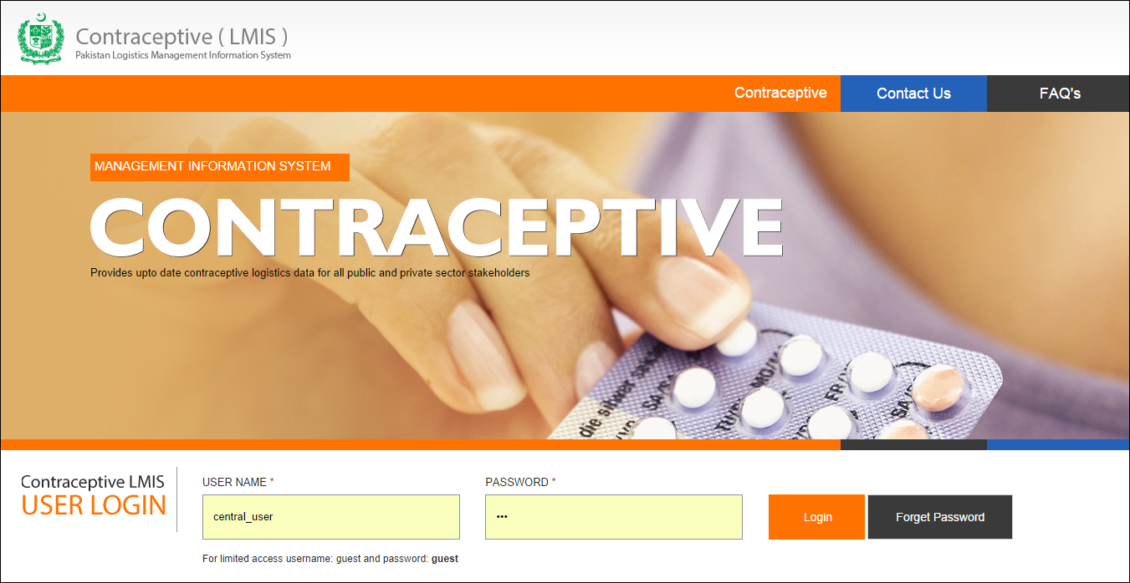

### Homepage Menu

The available menu items can be found on the top of homepage screen. The components are displayed adjacently, as shown in the image below:



### Contact Us Tab

The **Contact Us** tab contains addresses, telephone numbers and email addresses (where available) for key personnel as a system communication list. Therefore, the user of LMIS will be able to see contact details of other stakeholders and can contact them as needed.

### Frequently Asked Questions Tab

The menu also contains a **FAQ’s** tab in order to provide guidance towards the most frequently asked and critical questions.

For logging in to Contraceptive LMIS area:

1. Go to <http://c.lmis.gov.pk>
2. Click the button **Click Here** on the Contraceptives tab.

cLMIS login page will be displayed.  
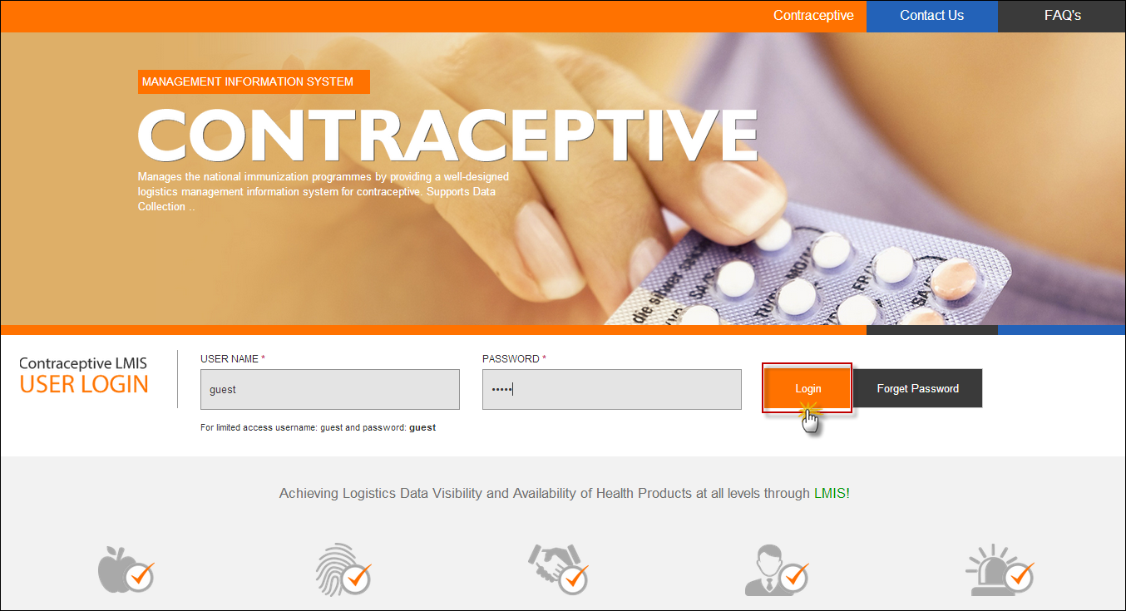

1. Specify the Username and Password provided to you by the Administrator.

|  |  |
| --- | --- |
| *C:\Users\isbah.zulfiqar\Desktop\1382615592_file_edit.png* | To login as a guest or anonymous user, you can simply provide the following credentials:  **Username**: guest **Password**: guest |

|  |  |
| --- | --- |
|  | You can change the password provided to you by the administrator. See “*Changing Your Password*” for details.  Never give out your password to anyone for security purposes. |

1. Click **Login**. The Contraceptive Logistics Management Information System Dashboard Screen displays.

### Changing Your Password

To change your cLMIS password:

1. Login to cLMIS application.

The welcome screen displays.

1. On the right-side of the application, the user login name appears.
2. Under the login name, click **Change Password** as shown in the image below:  
   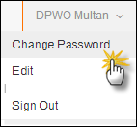
3. Specify the following:
   * **Old Password**: specify your old password.
   * **New Password**: specify the new password.
   * **Confirm New Password**: retype your password.

|  |  |
| --- | --- |
| *C:\Users\isbah.zulfiqar\Desktop\1382615592_file_edit.png* | Password Requirements  Your password must have a combination of a capital alphabet and one Numeric. |

|  |  |
| --- | --- |
|  | Never give out your password to anyone for security purposes. |

1. Click **Change Password**.  
   Your password will be changed successfully.

### Forgot Password

In case you have forgotten your password:

1. Open the cLMIS login page by entering the URL: <http://lmis.gov.pk>.
2. In the Login section, click **Forgot Password** as shown in the image below:  
     
   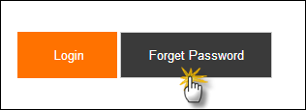

You will be redirected to the Forgot Password Page.

1. In the Email entry box, enter your email address as validated in your account information by the Administrator.   
   An email will be sent on your email address for resetting your password.
2. Click the Reset Password link in the email to go to reset password page.
3. Specify the following:
   * **New Password**: specify the new password.
   * **Confirm New Password**: retype your password.

|  |  |
| --- | --- |
| *C:\Users\isbah.zulfiqar\Desktop\1382615592_file_edit.png* | **Password Requirements**  Your password must have a combination of a capital alphabet and one Numeric. |

|  |  |
| --- | --- |
|  | Never give out your password to anyone for security purposes. |

1. Click **Change Password**.  
   Your password will be changed successfully.

### Logging Out

When signed in, click **Sign Out** on the right-side of the application, as shown in the image below:  
  
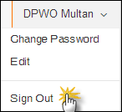

|  |  |
| --- | --- |
| Dashboards | **4** |
| for Contraceptive Logistics Management Information System | | |

This chapter explains the step-by-step instructions on the dashboard features that can be used by the Contraceptive Logistics Management Information system’s users.

# Introduction

Dashboard is a visual display of the most important analysis to achieve one or more objectives; consolidated and arranged on a single screen so the information can be monitored at a glance.

User can view following dashboards by default:

* Public Sector Stakeholders
* Private Sector Stakeholders

## Public Sector Dashboard

This dashboard allows users to quickly view analysis in a graphical manner for the selected public sector stakeholder.

* **Stock Out vs Over Stock**

This graph shows the stock out and over stock rates in district/sub-district (field) stores for different products. This also mentions the reporting rate on which this analysis is drawn.

* **Stock Issued vs Stock on Hand (SOH) in Central Warehouse**

This graph is showing the comparison between the issued stock and the stock on hand (SOH) for all products in the central warehouse.

* **Consumption vs Average Monthly Consumption (AMC)**

This graph is showing that the comparison between consumption and average monthly consumption of all products for the selected stakeholder and also shows the reporting rate on which this analysis is drawn.

* **Couple Year Protection (CYP)**

This graph is showing the product-wise CYP for the selected month.

* **Couple Year Protection (CYP) Map**

This map is showing the product-wise CYP for the selected month.

Users can apply following filters.

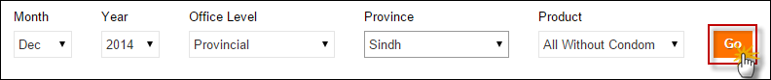

* **Month:** select the month from the drop-down list
* **Year:** select the year from the drop-down list.
* **Office Level:** select the Office Level from the drop-down list.
* **Province:** select the Province from the drop-down list.
* **District:** select the district for which you want to view report.
* **Product:** user can either select all products with or without condoms because the logistic analysis of condoms changes the maximum range of graphs to a level where analysis of other products is not shown properly.

Click **Go** to view Public Sector Dashboard.

### Stock Out vs Over Stock

Public Sector dashboard shows the stock out and over stock rates in district/sub-district (field) stores for different products. This also mentions the reporting rate on which this analysis is drawn. Users can view the comparison graph for stock out and over stock of products on the horizontal axis and District percentage on the vertical axis.

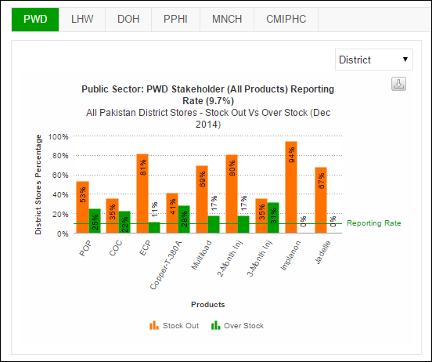

Users can also export charts in JPEG, PNG, PDF and SVG format.

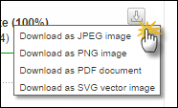

### Stock Issued vs Stock on Hand (SOH) in CWH

Public Sector dashboard shows the comparison between the issued stock and the stock on hand (SOH) for all products in the central warehouse.

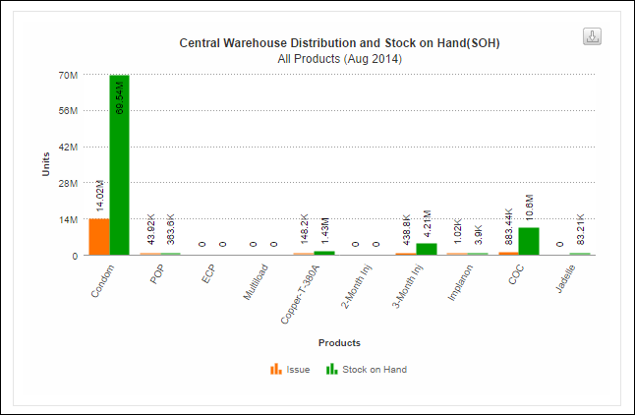

Users can also export charts in JPEG, PNG, PDF and SVG format.



### Consumption vs Average Monthly Consumption (AMC)

Public Sector dashboard shows the comparison between consumption and average monthly consumption of all products for the selected stakeholder and also shows the reporting rate on which this analysis is drawn.

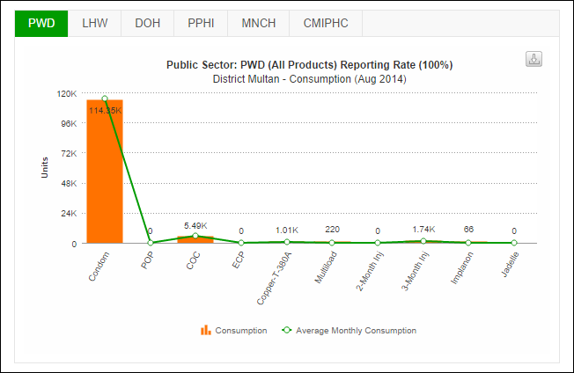

Users can also export charts in JPEG, PNG, PDF and SVG format.



### Couple Year Protection (CYP)

Public Sector dashboard shows the product-wise CYP for the selected month.

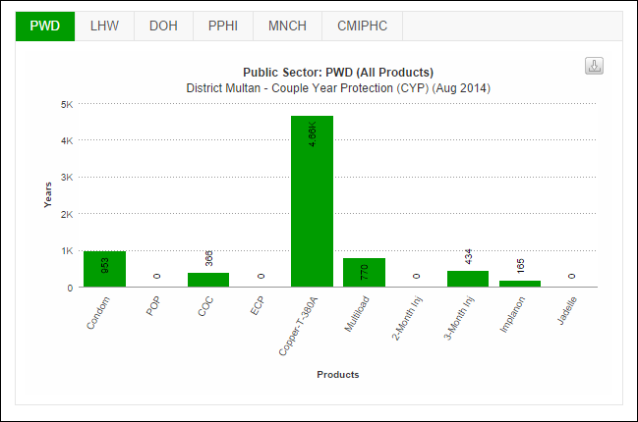

Users can also export charts in JPEG, PNG, PDF and SVG format.



### Couple Year Protection (CYP) Map

This map shows the product-wise CYP for the selected month.

Select the stakeholder and the product from the drop-down menu and click **GO.**

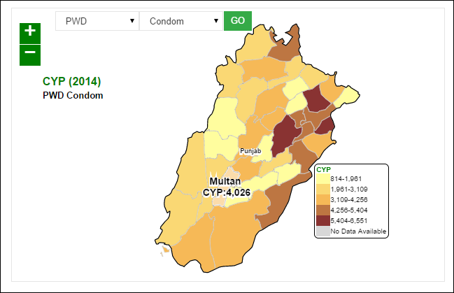

## Private Sector Dashboard

This dashboard allows users to quickly view analysis in a graphical manner for the selected private sector stakeholder.

* **Stock Out vs Over Stock**

This graph shows the stock out and over stock rates in district/sub-district (field) stores for different products. This also mentions the reporting rate on which this analysis is drawn.

* **Stock Issued vs Stock on Hand (SOH) in Central Warehouse**

This graph is showing the comparison between the issued stock and the stock on hand (SOH) for all products in the central warehouse.

* **Consumption vs Average Monthly Consumption (AMC)**

This graph is showing that the comparison between consumption and average monthly consumption of all products for the selected stakeholder and also shows the reporting rate on which this analysis is drawn.

* **Couple Year Protection (CYP)**

This graph is showing the product-wise CYP for the selected month.

* **Couple Year Protection (CYP) Map**

This map is showing the product-wise CYP for the selected month.

Users can apply following filters.



* **Month:** select the month from the drop-down list
* **Year:** select the year from the drop-down list.
* **Office Level:** select the Office Level from the drop-down list.
* **Province:** select the Province from the drop-down list.
* **District:** select the district for which you want to view report.
* **Product:** user can either select all products with or without condoms because the logistic analysis of condoms changes the maximum range of graphs to a level where analysis of other products is not shown properly.

Click **Go** to view Private Sector Dashboard.

### Stock Out vs Over Stock

Private Sector dashboard shows the stock out and over stock rates in district/sub-district (field) stores for different products. This also mentions the reporting rate on which this analysis is drawn. Users can view the comparison graph for stock out and over stock of products on the horizontal axis and District percentage on the vertical axis.

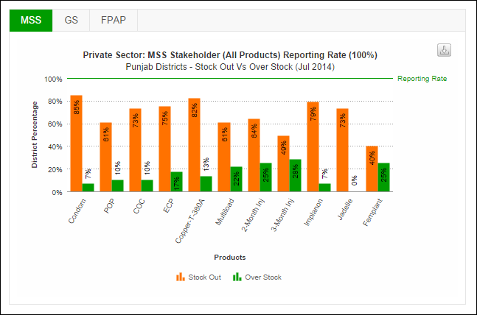

Users can also export charts in JPEG, PNG, PDF and SVG format.



### Stock Issued vs Stock on Hand (SOH) in CWH

Private Sector dashboard shows the comparison between the issued stock and the stock on hand (SOH) for all products in the central warehouse.

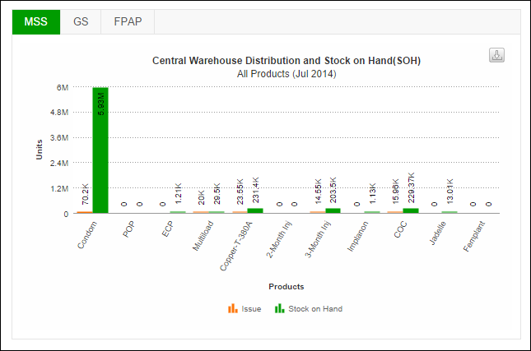

Users can also export charts in JPEG, PNG, PDF and SVG format.



### Consumption vs Average Monthly Consumption (AMC)

Private Sector dashboard shows the comparison between consumption and average monthly consumption of all products for the selected stakeholder and also shows the reporting rate on which this analysis is drawn.

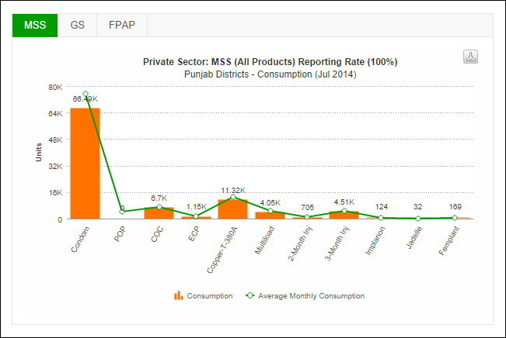

Users can also export charts in JPEG, PNG, PDF and SVG format.



### Couple Year Protection (CYP)

Private Sector dashboard shows the product-wise CYP for the selected month.

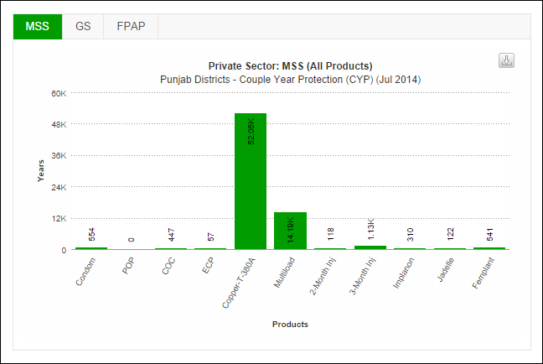

Users can also export charts in JPEG, PNG, PDF and SVG format.



### Couple Year Protection (CYP) Map

This map shows the product-wise CYP for the selected month.

Select the stakeholder and the product from the drop-down menu and click **GO.**

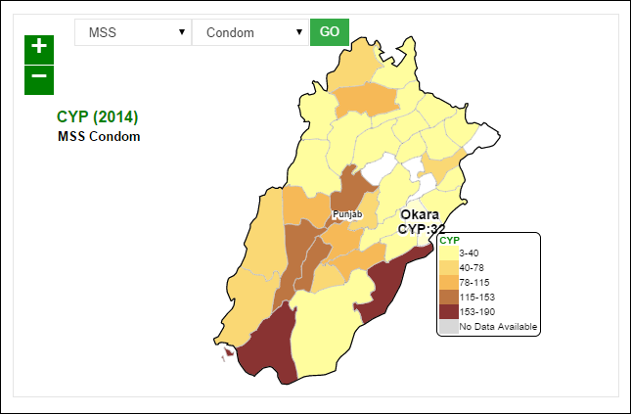

|  |  |
| --- | --- |
| Reports | **5** |
| for Contraceptive Logistics Management Information System | |

This chapter explains the step-by-step instructions on the report features that can be used by the Contraceptive Logistics Management Information system’s users.

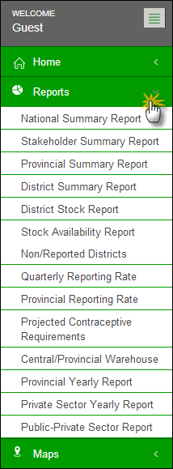When a user clicks the **Reports** tab, the application shows the list of all available reports. These reports include National, Provincial and District level Reports of both public and private sectors. It also includes Stakeholder Reports, Summary Reports, Field Reports and Stock Availability Reports. Quarterly and Provincial Reporting Rate has also been added in the list of available reports.

Click the **Reports** tab from the main menu to show a drop down list which includes a range of reports.

### National Summary Report

The National Summary Report provides periodic consumption, [average monthly consumption](http://115.186.136.214:8081/paklmis_final/plmis_src/reports/content-detail.php?title=pop_amc) (AMC), stock on hand (SOH), months of stock (MOS) and couple years of protection (CYP) by each commodity for a particular month. The data is summed up for all stakeholders as well as the public and private sector in each commodity to national level.

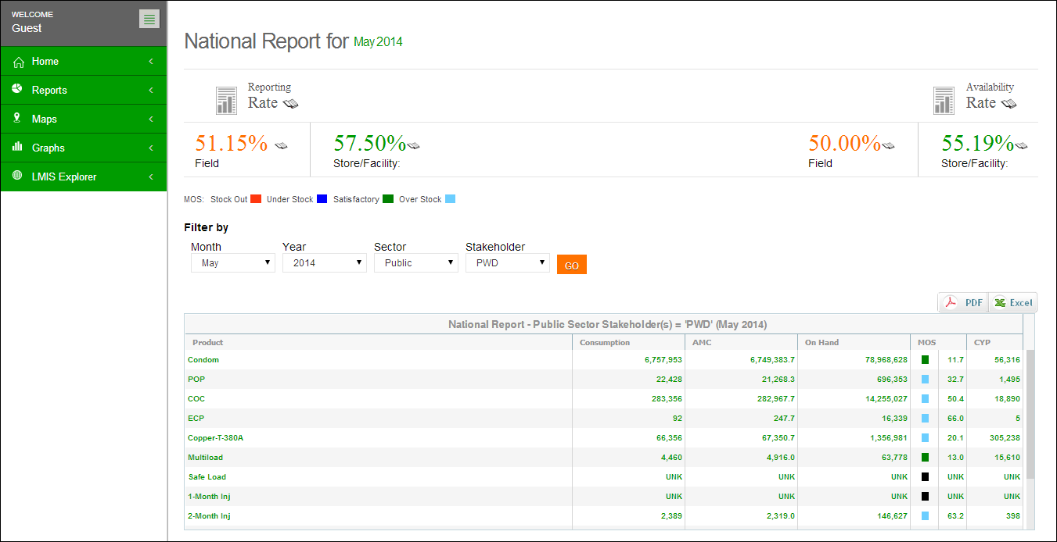

**Use Filter options to filter data in the table below**

**Table displays National Summary of each contraceptive**

**Reporting and Availability Rates are displayed here**

The national summary report not only provides the summary statistics but also opens up various options for users to explore further into the data through various links.

The Header bar displays the Reporting Rate i.e. rate of stores reported on the left side while on the right side, the Availability Rate i.e. rate of stock available is shown. You can click the  icon to open the Reporting Rate and Stock Availability rate reports directly.

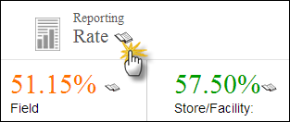Click on **Reporting Rate** to view the warehouse stores which have not reported for a particular month.

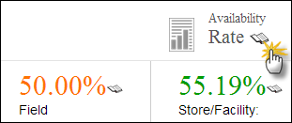Click on **Availability Rate** to view the stock availability rate at selected level i.e. National, Provincial and District level.

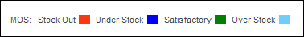MOS legends display the MOS Stock values. A black box represents an Unknown value.

**Filters**

You can use Month and Year filters to filter values based on Month and Year.

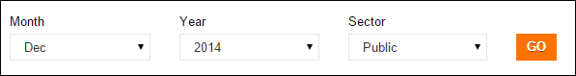

**Report Table**

* **Product**: It displays the list of products.
* **Consumption:** It displays the consumption data of contraceptives for the last reported month. The data for each product is the sum of all reporting levels.
* **Average Monthly Consumption (AMC):** It is calculated as average of aggregated consumption of the last three non-zero consumption months.
* **Stock on Hand (SOH):** It is the amount of product on hand in order to monitor stock positions and anticipate stock outs in advance.
* **Months of Stock (MOS):** It is the estimate of number of months the stock will last. This calculation is based on average monthly consumption.
* **Couple Years of Protection (CYP):** It is the estimated protection provided by contraceptive methods during a one-year period, based upon the volume of all contraceptives consumed during that period.

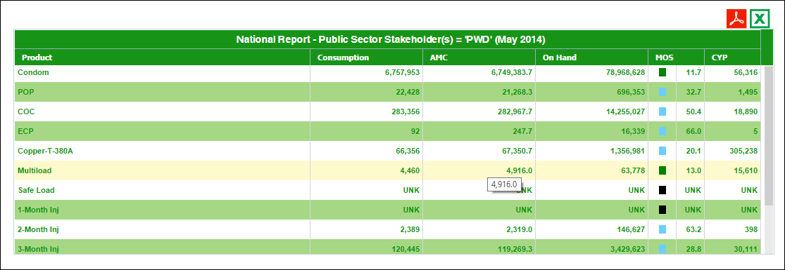

### Stakeholder Summary Report

This report provides information about periodic consumption and average monthly consumption of all stakeholders for a product.

**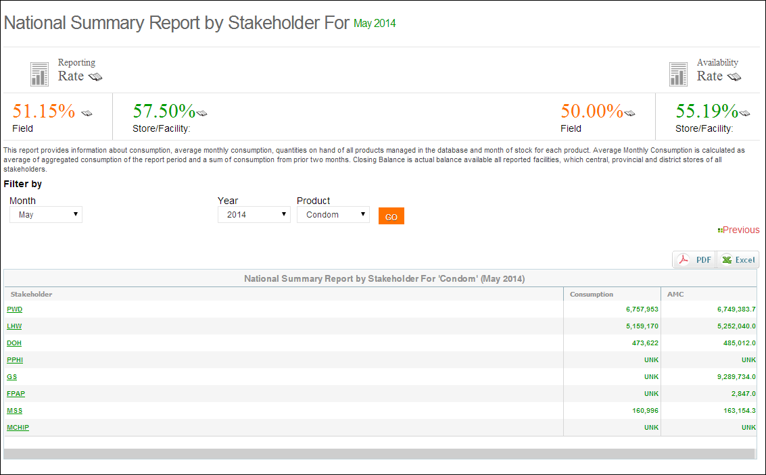**

**Click GO.**

**Click here to generate report in PDF & Excel File.**

**Select Product**

Filtering options are also available on the basis of month, year and product as shown in the “Filter by” menu.

The Header bar displays the Reporting Rate i.e. rate of stores reported on the left side while on the right side, the Availability Rate i.e. rate of stock available is shown. You can click the  icon to open the Reporting Rate and Stock Availability rate reports directly.

Click on **Reporting Rate** to view the warehouse stores which have not reported for a particular month.

Click on **Availability Rate** to view the stock availability rate at selected level i.e. National, Provincial and District level.

**Filters**

You can use **Month**, **Year**, and **Product** filters to filter values in the table.

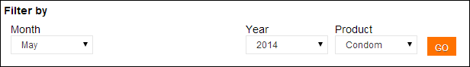

**Report Table**

* **Stakeholder:** It displays the list of identified stakeholders. By clicking on any of the stakeholders listed in Stakeholder Summary Report, the province wide summary of that particular stakeholder will appear.
* **Consumption:** It displays the consumption data of contraceptives for the last reported month. The data for each contraceptive is the sum of all reporting levels.
* **Average Monthly Consumption (AMC):** It is calculated as average of aggregated consumption of the last three non-zero consumption months.

**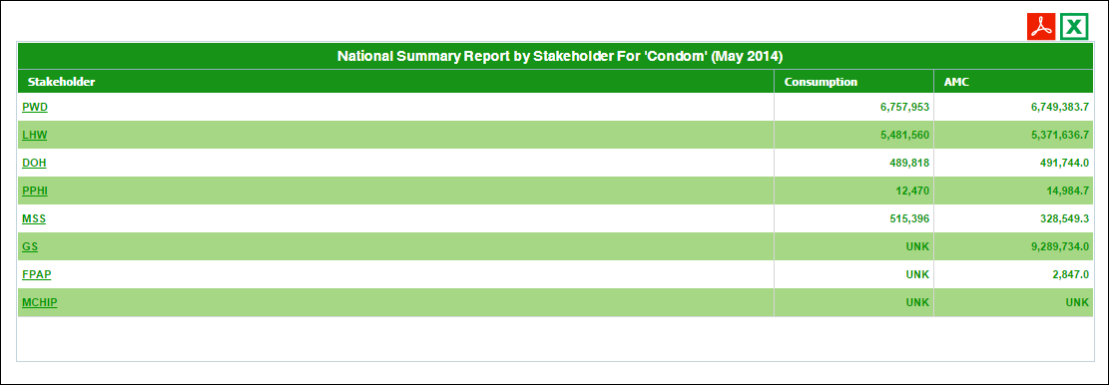**

### Provincial Summary Report

Provincial summary report provides periodic consumption, [average monthly consumption](http://115.186.136.214:8081/paklmis_final/plmis_src/reports/content-detail.php?title=pop_amc) (AMC), stock on hand (SOH), months of stock (MOS) and Couple Years of Protection (CYP) by each commodity for a particular month. The data is summed up for all stakeholders as well as the public and private sector in each commodity to provincial level.

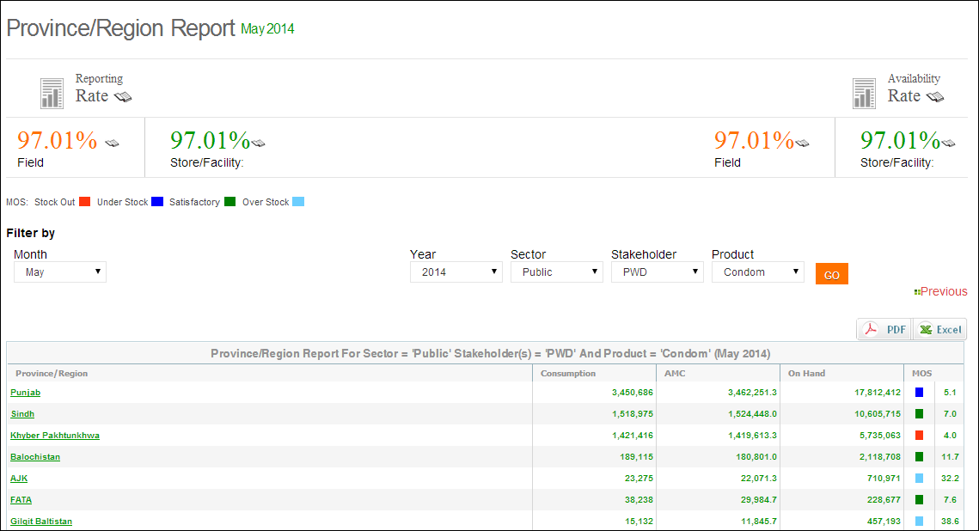

**Report for each province is displayed in the report table**

**Select Product & Stakeholder**

**Click GO.**

The provincial summary report not only provides the summary statistics but also opens up various options for users to explore further into the data through various links.

The Header bar displays the Reporting Rate i.e. rate of stores reported on the left side while on the right side, the Availability Rate i.e. rate of stock available is shown. You can click the  icon to open the Reporting Rate and Stock Availability rate reports directly.

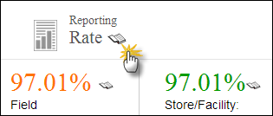Click on **Reporting Rate** to view the warehouse stores which have not reported for a particular month.

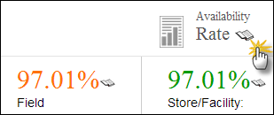Click on **Availability Rate** to view the stock availability rate at selected level i.e. National, Provincial and District level.

MOS legends display the MOS Stock values. A black box represents an Unknown value.

**Filters**

You can use Month, Year, Sector, Stakeholder and Product filters to filter values.



**Report Table**

* **Province**: It displays the list of provinces. By clicking on any of the provinces listed in Provincial Summary Report, the district wide summary of that particular stakeholder will appear.
* **Consumption:** It displays the consumption data of contraceptives for the last reported month. The data for each product is the sum of all reporting levels.
* **Average Monthly Consumption (AMC):** It is calculated as average of aggregated consumption of the last three non-zero consumption months.
* **Stock on Hand (SOH):** It is the amount of product on hand in order to monitor stock positions and anticipate stock outs in advance.
* **Months of Stock (MOS):** It is the estimate of number of months the stock will last. This calculation is based on average monthly consumption.

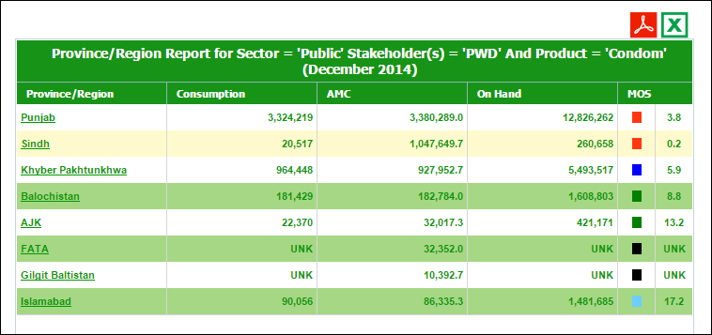

### District Summary Report

This report provides periodic consumption, [average monthly consumption](http://115.186.136.214:8081/paklmis_final/plmis_src/reports/content-detail.php?title=pop_amc) (AMC), stock on hand (SOH), months of stock (MOS) and couple years of protection (CYP) by each commodity for a particular month. The data is summed up for all public and private sector stakeholders for each commodity to the district level.

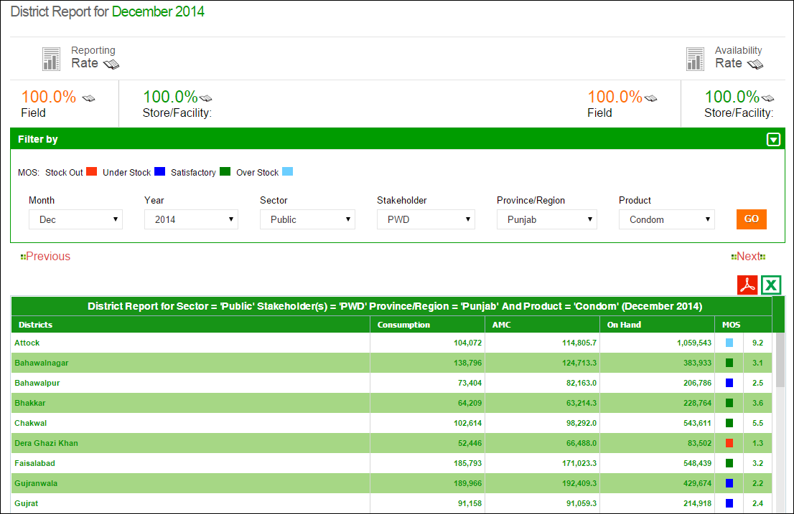

**Report for each district is displayed in the report table**

**Click GO.**

**Select Stakeholder, Province & Product**

The Header bar displays the Reporting Rate i.e. rate of stores reported on the left side while on the right side, the Availability Rate i.e. rate of stock available is shown. You can click the  icon to open the Reporting Rate and Stock Availability rate reports directly.

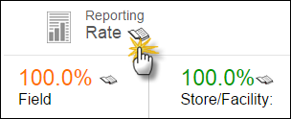Click on **Reporting Rate** to view the warehouse stores which have not reported for a particular month.

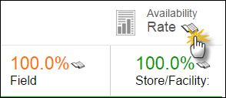Click on **Availability Rate** to view the stock availability rate at selected level i.e. National, Provincial and District level.

****MOS legends display the MOS Stock values.Black box represents Unknown value.

**Filters**

You can use Month, Year, Province/Region and Product filters to filter values in the table.



**Report Table**

* **Districts**: It displays the list of districts.
* **Consumption:** It displays the consumption data of contraceptives for the last reported month. The data for each product is the sum of all reporting levels.
* **Average Monthly Consumption (AMC):** It is calculated as average of aggregated consumption of the last three non-zero consumption months.
* **Stock on Hand (SOH):** It is the amount of product on hand in order to monitor stock positions and anticipate stock outs in advance.
* **Months of Stock (MOS):** It is the estimate of number of months the stock will last. This calculation is based on average monthly consumption.

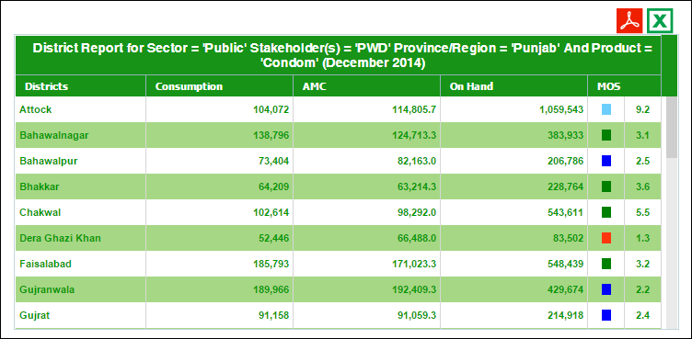

### District Stock Yearly Report

This report shows month wise stock issued or received for any stakeholder in a particular district of a province for the previous year. User is provided with a set of filters that are helpful to extract data by province, month, year, or stakeholder. Type filter provides an option to show received or issued stock.

**Select Province, Stakeholder, Product & Type**

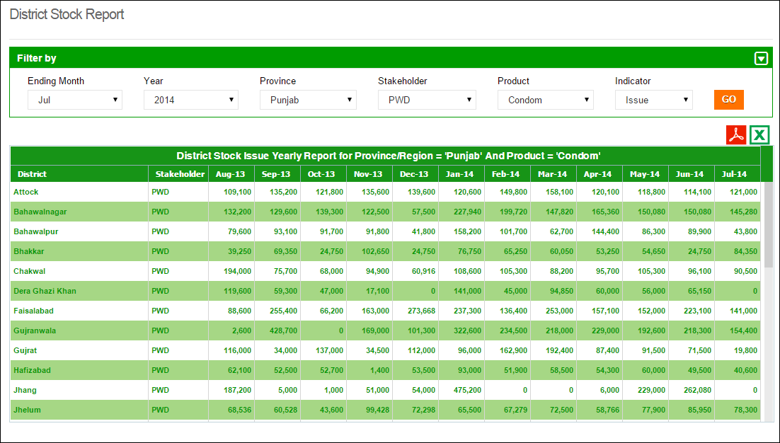

**Click GO.**

**Report for each district is displayed in the report table**

**Select Month & Year**

You can filter data on the basis of month, year, province, stakeholder, product and indicator. There are four indicators present which include:

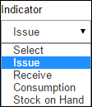**Issue:** Stock issued from district stores to health facilities (field)

**Receive:** Stock received from central warehouse Karachi

**Consumption:** Stock issued to the end users from health facilities in the district

**Stock on Hand:** Stock present in all stores (district and health facilities) in the district

### Stock Availability Report

The Stock Availability Report provides the availability rate and the months of stock for each store and facility. The availability rate for central warehouse, provinces and districts for a particular month by stakeholder can be filtered from the menu provided.

**Use Filter options to filter data in the table below**

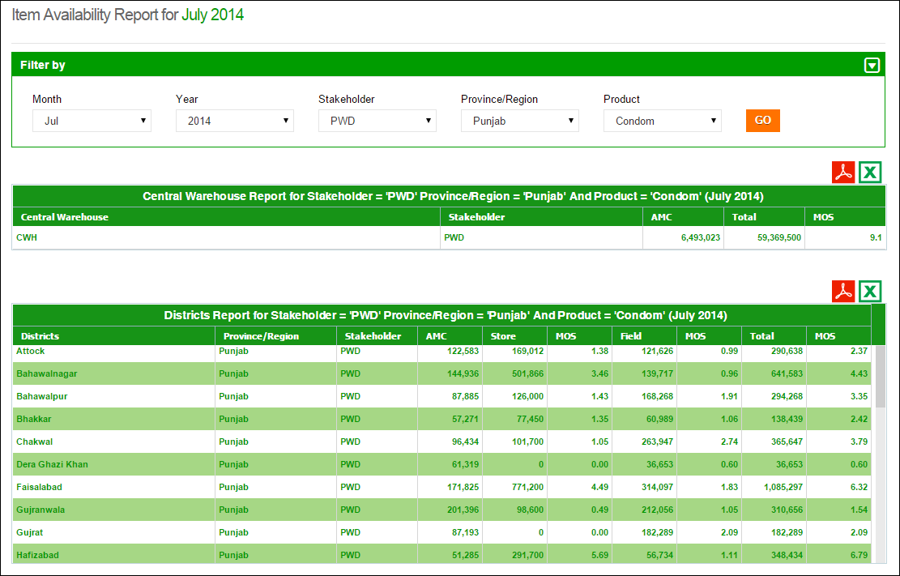

**Show filtered results of Districts.**

**Generate PDF\Excel**

**Select province.**

**Show filtered results of central warehouses.**

The report shows the in-country available stock based on filters applied at all levels of supply chain and stocks are also translated in months of stock calculated from Average Monthly Consumption. Separate months of stock for field and store are provided in addition to the aggregate for the two. In this report, only those stores appear which have reported for the period applied to view the report.

### Non/Reported Districts

The Non-reported Districts Report provides the reporting rate for provinces as well as districts (by stakeholders) which have not reported for a particular month. If “all” is selected from the option “stakeholder”, all district level stakeholders not reporting for a particular month will appear in the list. For example, a district name will appear twice if both DPIU and DPWO have not reported.

**Use Filter options to filter data in the table below**

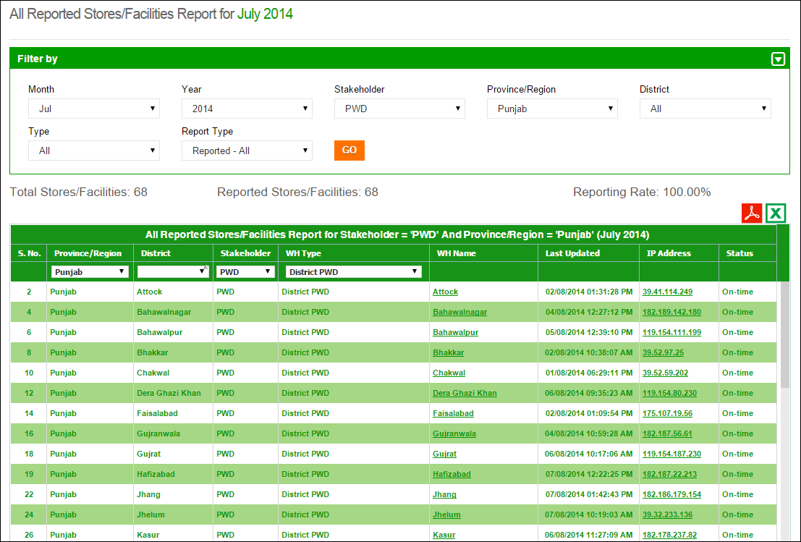

**Table displays non-reported stores data**

**Field Reporting Rate**

By selecting the type as **Field** in the filter, user can view the non-reported facilities in the field (by stakeholders) which have not reported for a particular month. If “all” is selected from the option “stakeholder” all stakeholders not reporting for a particular month will appear in the list.

**Use Filter options to filter data in the table below**

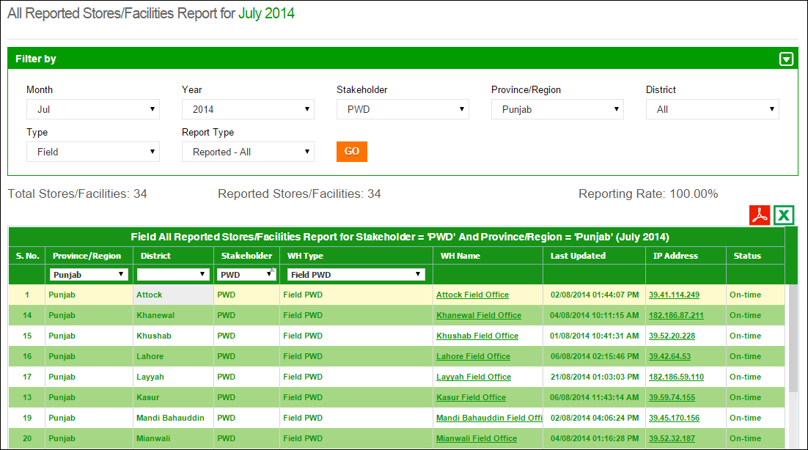

**Select Field**

**Table displays non-reported stores data in the field**

**District Reporting Rate**

By selecting the type as **District** in the filter, user can view the non-reported stores in the districts (by stakeholders) which have not reported for a particular month. If “all” is selected from the option “stakeholder” all stakeholders not reporting for a particular month will appear in the list.

**Use Filter options to filter data in the table below**

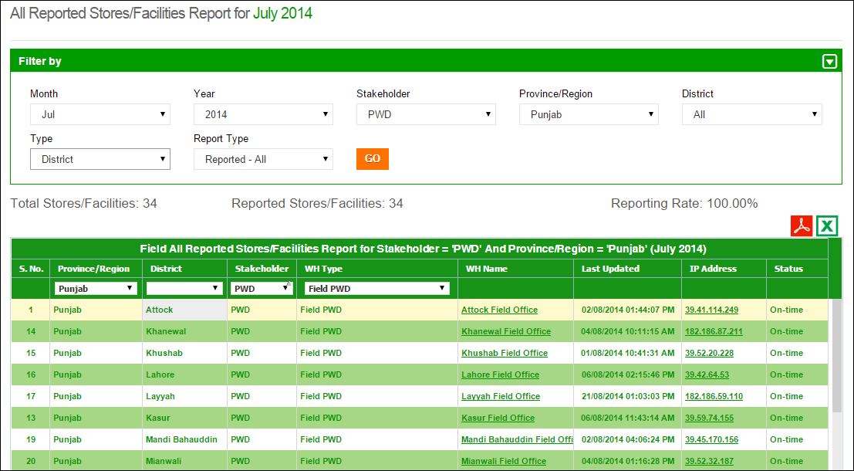

**Select District**

**Table displays non-reported stores data for districts**

### Quarterly Reporting Rate

By selecting the desired quarter of a year in the filter, user can view the reporting rate at the provincial level (by stakeholders) for each month of the quarter.

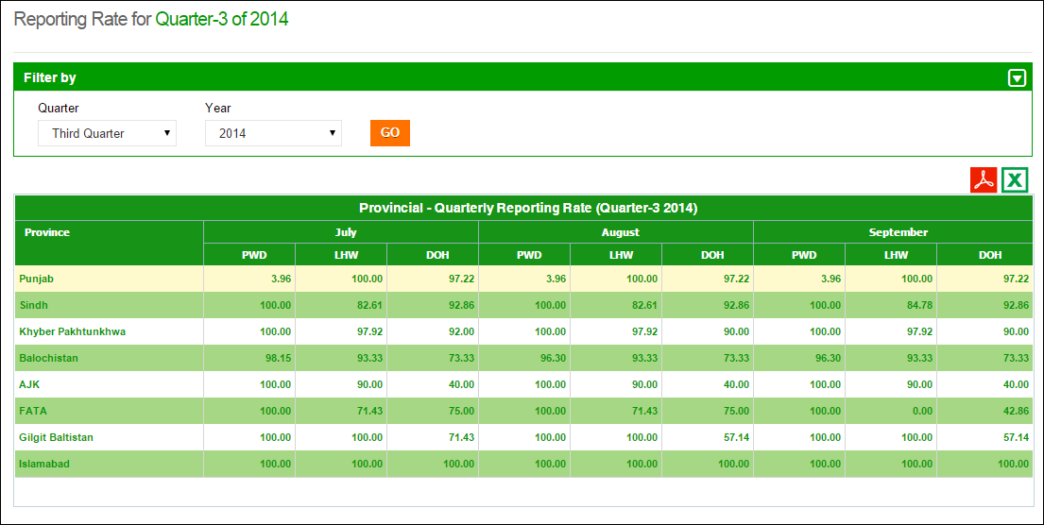

**Select Quarter & Year**

**Table displays the quarterly reporting rate for each province**

### Provincial Reporting Rate

This report shows the provincial reporting rates for particular public sector stakeholders i.e. PWD, LHW and DOH. User can filter report on the basis of month and year.

The filtered results of the stakeholders will be displayed in the form of district reporting rate, field reporting rate and total (overall) reporting rate.

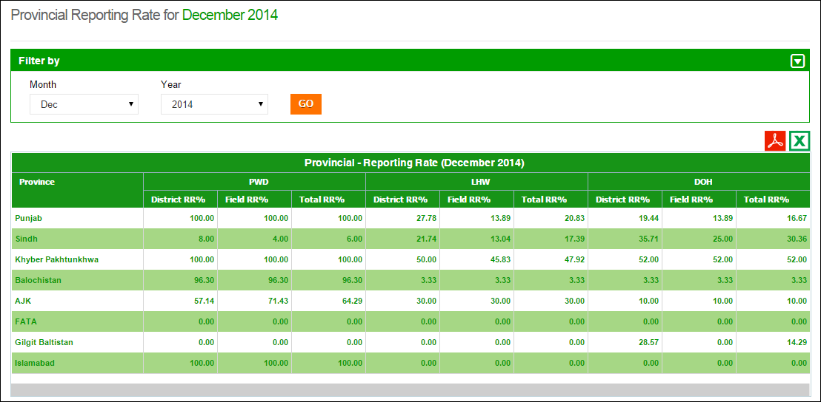

**Table displays the provincial reporting rate for each stakeholder**

**Select Month & Year**

### Projected Contraceptive Requirements

This report shows the projected contraceptive requirement for a selected product in each district based on the previous consumption of the product. User can select the ending month, year, demand for number of months, type, stakeholder and province to estimate the contraceptive requirement for each district. The report shows average monthly consumption (AMC), stock available in district store, field and sum of the two for the selected ending month. It also shows desired stock level for 3 months and the requested replenishment stock for the selected store.

**Select Sector, Stakeholder & Province**

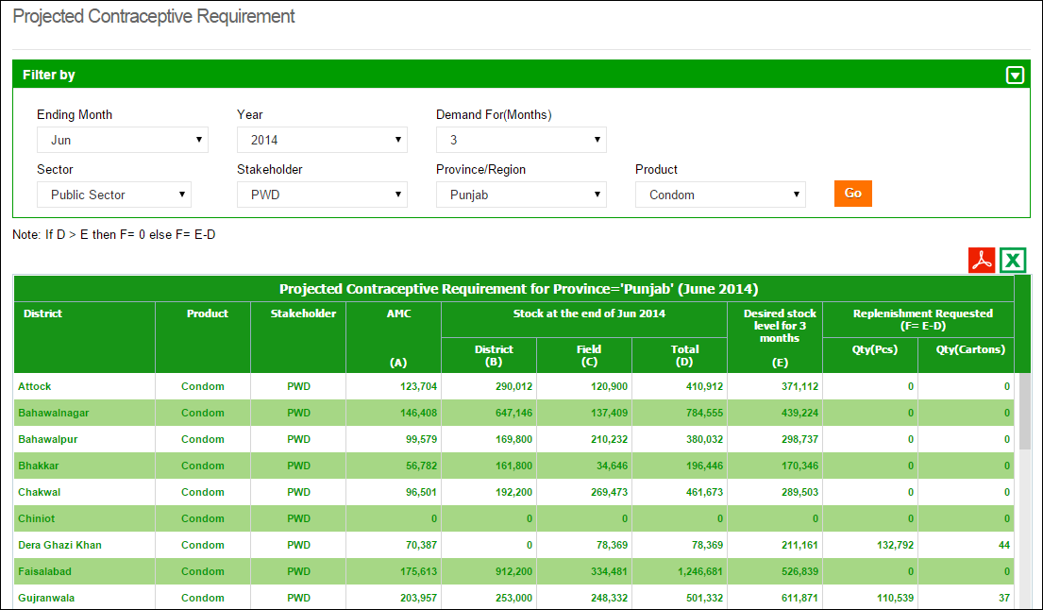

**Select Month & Year**

**Click Go**

### Central/Provincial Warehouse Report

This report shows the monthly values of different inventory indicators i.e. Issued, Stock on Hand and received stock of stakeholder’s central or provincial warehouse / stores. User can filter report on the basis of month, stakeholder and type of store i.e. Provincial and Central warehouse.

**Select Stakeholder, Indicator & Warehouse**

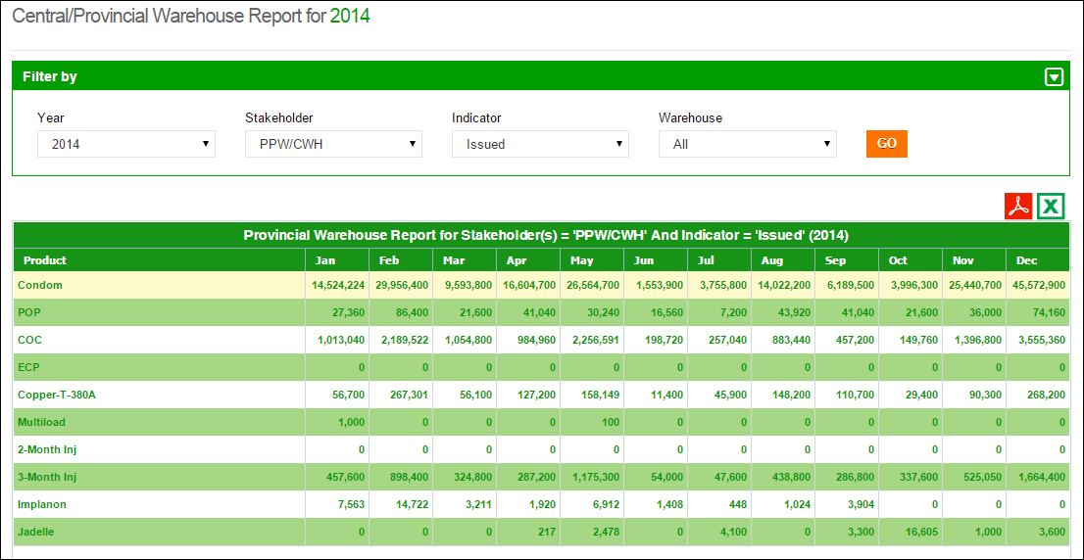

**Click GO**

**Select Year**

### Provincial Yearly Report

This report is to view provincial yearly report month for the selected stakeholder, indicator and year. There are five main indicators that can be viewed i.e. Issuance (Consumption), Couple Years of Protection (CYP), Stock on Hand and Received (District and Field). This is aggregate of the selected indicator from district and field. User can filter report on the basis of stakeholder and Province/Region.

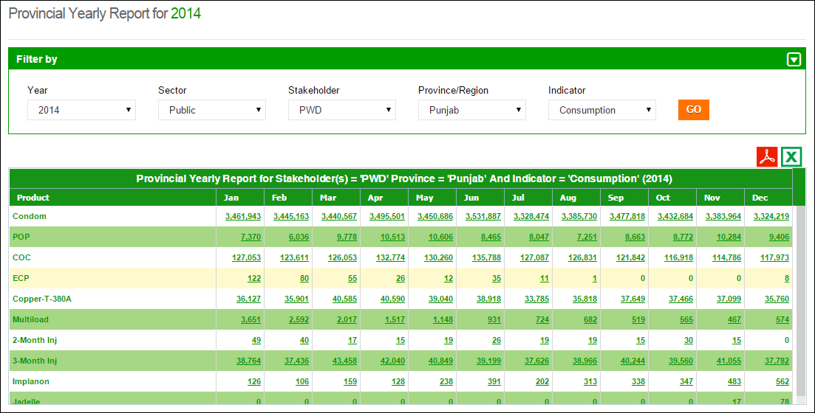

**Select Year**

**Click GO**

**Select Stakeholder, Province & Indicator**

### Private Sector Yearly Report

This report shows the monthly values of different inventory indicators i.e. Consumption, Stock on Hand and received stock for private sector stakeholder’s warehouses/stores in a particular month. User can filter on the basis of month, indicator and stakeholder.

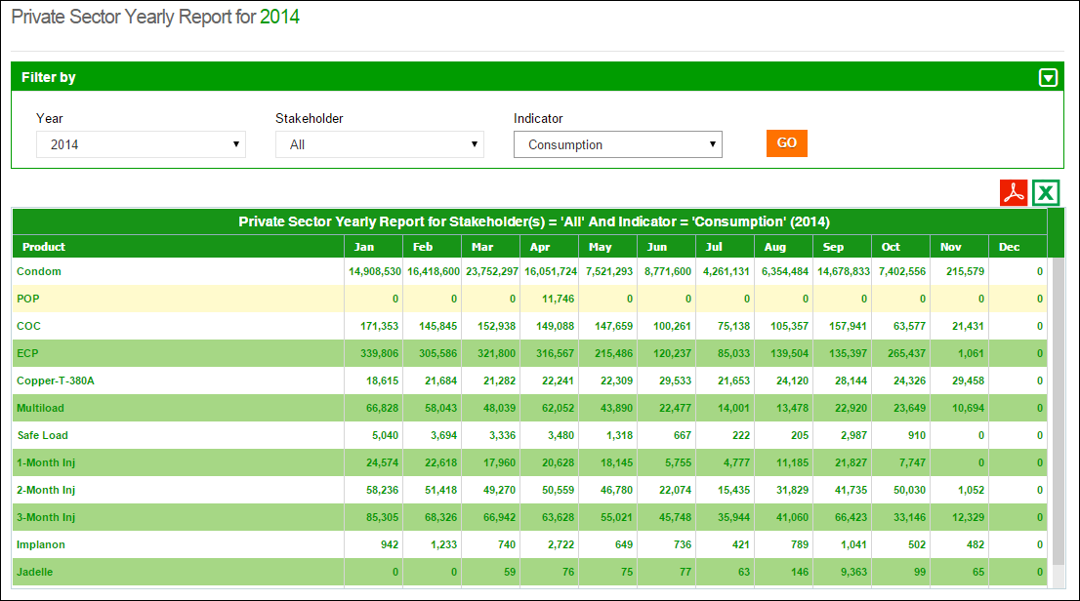

**Click GO**

**Select Stakeholder & Indicator**

**Select Year**

### Public-Private Sector Report

This report is to view the public and private sector share at National, Provincial, District and Field level on some indicators i.e. Consumption, AMC, Stock on Hand and MOS. User can filter on the basis of month and geographical levels i.e. National, Provincial, District and Facility.

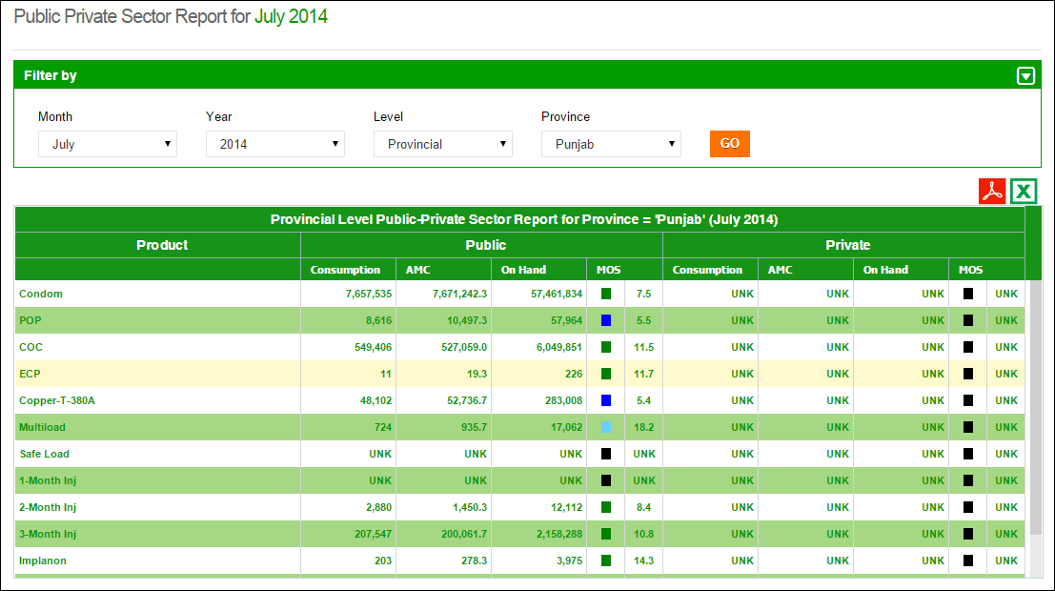

**Select Month &Year**

**Click GO**

**Select Level of Report**

|  |  |
| --- | --- |
| Maps | **6** |
| for Contraceptive Logistics Management Information System | | |

This chapter explains the step-by-step instructions on the map features that can be used by the Contraceptive Logistics Management Information system’s users.

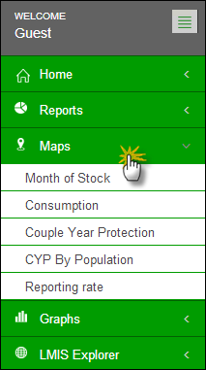cLMIS also has the capability of generating easy to interpret maps with color codes. These maps can be viewed by selecting the “Maps” tab in the menu. The drop down menu will be displayed as follows:

Once the indicator for which the map is to be viewed is selected, the user will be directed towards a page to select from various filters.

### Month of Stock Map

Month of Stock (MOS) map provides many filter options to the user. User can select Month, Year, Province/Region, Product as well as Level to analyze MOS for each district in the selected province. The detailed information can be seen once the user clicks a particular district on the map.

**Select the Sector & Stakeholder**

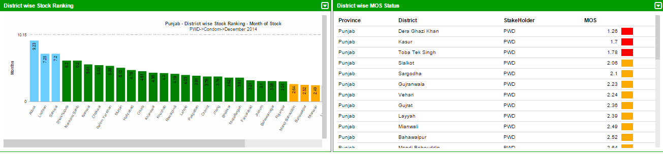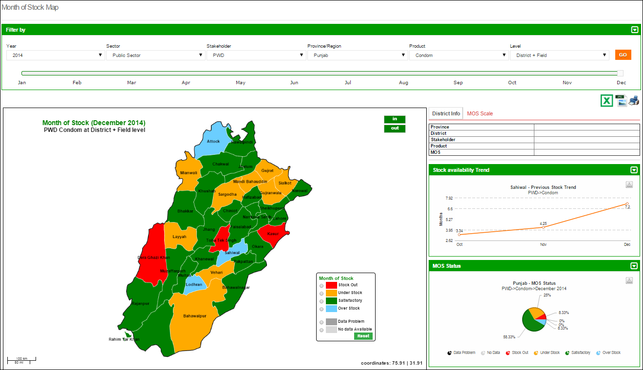

**Select the Province and Product**

**Select Year**

**Click GO**

### Consumption Map

Consumption map provides user with filter options such as Month, Year, Sector, Stakeholder, Province/Region, Product as well as Type (Consumption and Avg. Monthly Consumption) to analyze product consumption for each district in the selected province. The detailed information can be seen once the user clicks a particular district on the map.

**Select the Sector, Stakeholder & Province**

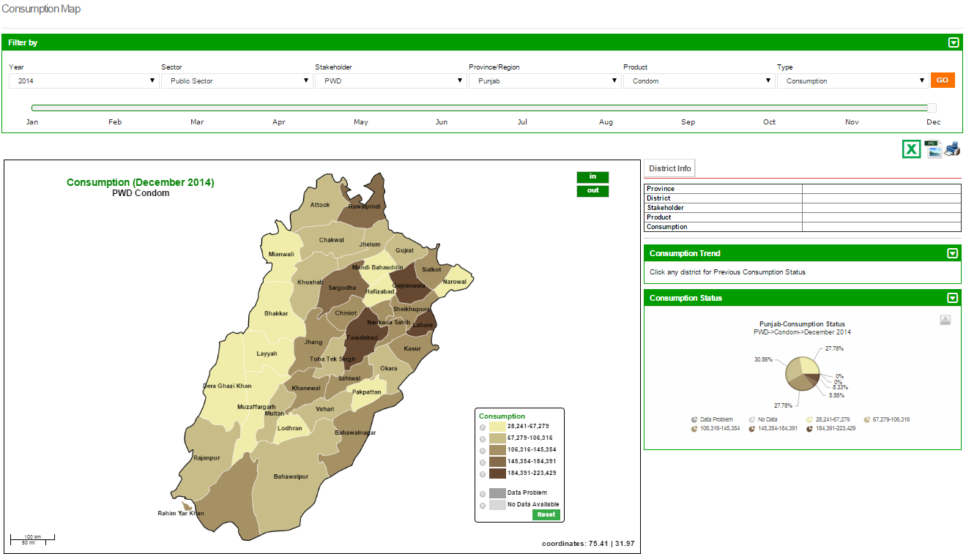

**Click GO**

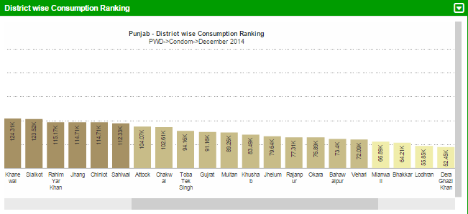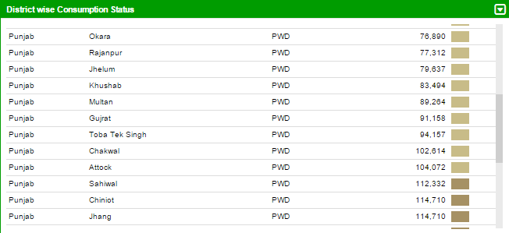

**Select the Product & Type**

**Select Year**

### Couple Year Protection Map

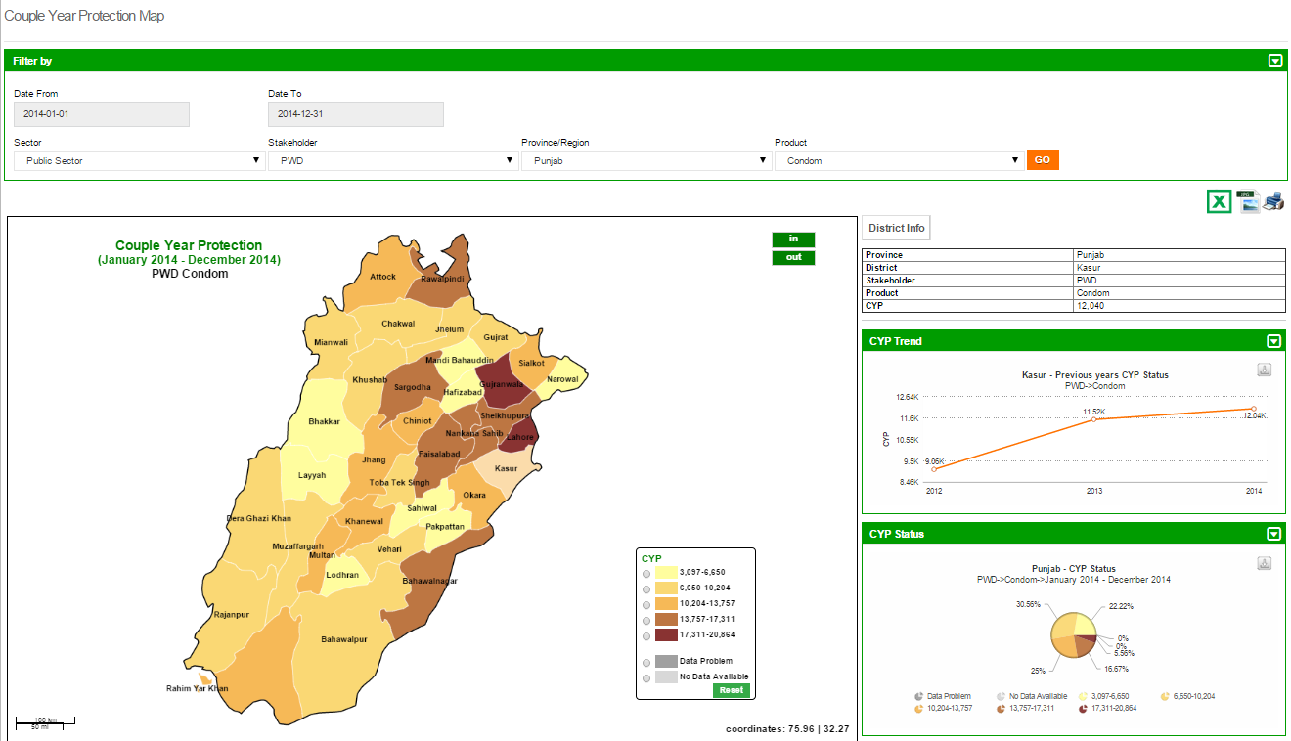Couple Year Protection map provides user with filter options such as Month, Year, Sector, Stakeholder, Province/Region and Product to analyze number of couples protected for each district in the selected province. The detailed information can be seen once the user clicks a particular district on the map.

**Select the Sector & Stakeholder**

**Click GO**

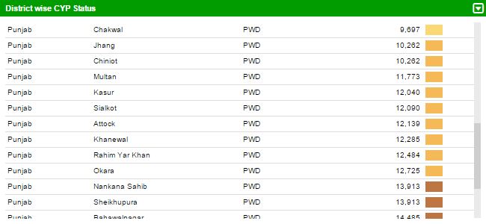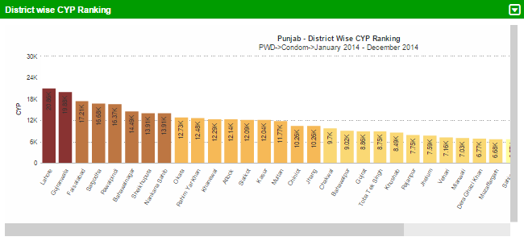

**Click a District on map to see details**

**Select the Province and Product**

**Select the Date From, To**

### CYP by Population Map

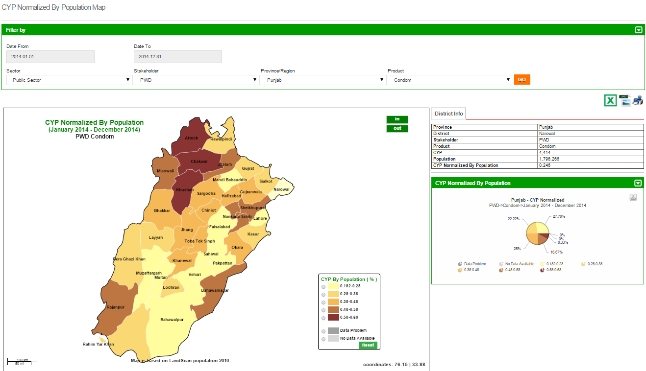Couple Year Protection map can also be normalized based on the population of the province. It provides user with filter options such as Month, Year, Sector, Stakeholder, Province/Region and Product to analyze number of couples protected for each district in the selected province based on the population of that district. The detailed information can be seen once the user clicks a particular district on the map.

**Select the Sector & Stakeholder**

**Click GO**

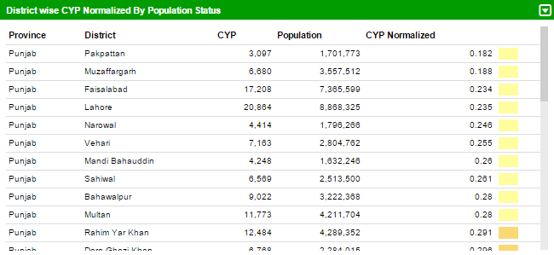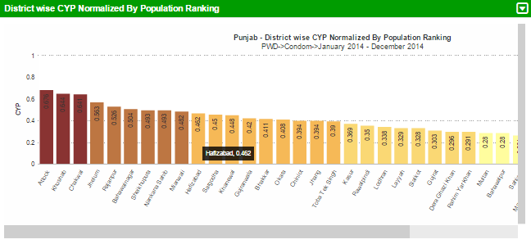

**Click a District on map to see details**

**Select the Province and Product**

**Select the Date From, To**

### Reporting Rate Map

Reporting rate map shows the number of stores and facilities which have provided the report for each district. User can see filter options such as Month, Year, Sector, Stakeholder, Province/Region and Product to analyze the reporting rate for each district in the selected province based on the number of facilities in that district. The detailed information can be seen once the user clicks a particular district on the map.

**Select the Sector & Stakeholder**

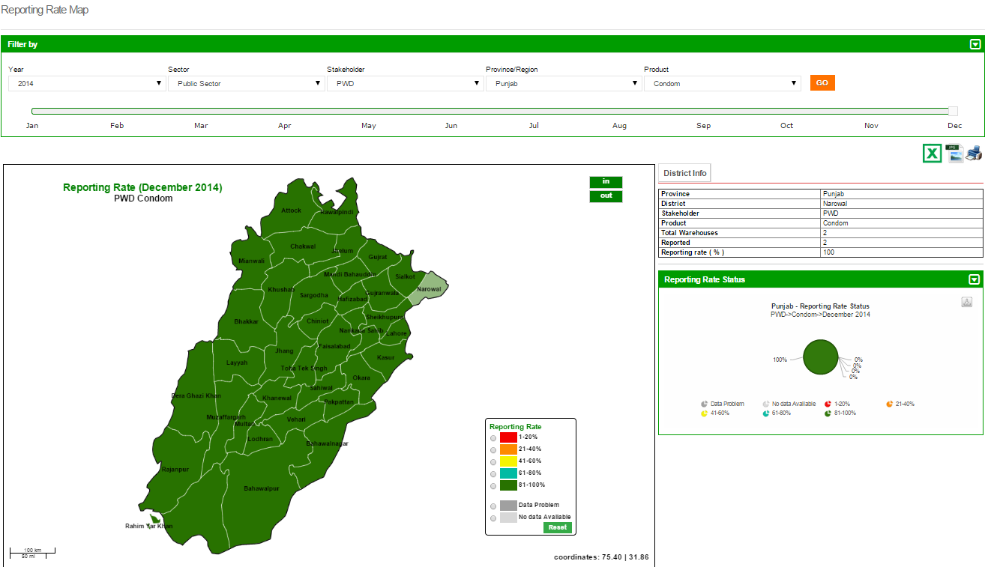

**Click GO**

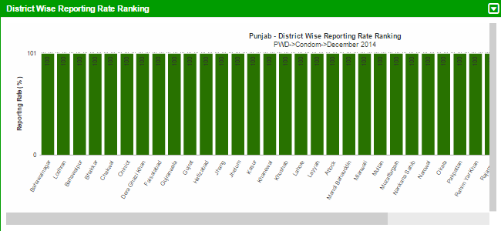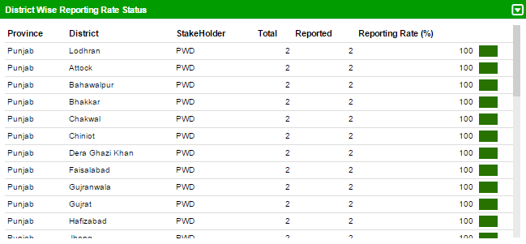

**Click a District on map to see details**

**Select the Province and Product**

**Select Year**

**Click GO**

|  |  |
| --- | --- |
| Graphs | **7** |
| for Contraceptive Logistics Management Information System | | |

This chapter explains the step-by-step instructions on the graph features that can be used by the Contraceptive Logistics Management Information system’s users.

The LMIS also has the capability of generating easy to interpret graphs. Simple and comparative graphs can be viewed by selecting the “Graphs” tab. The drop down menu will display:

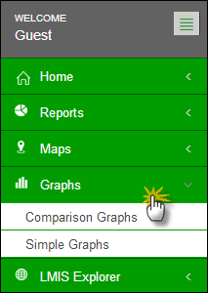

Once simple or comparison graphs is selected, the user is directed towards a page from where s/he can choose various options to create graphs.

### Comparison Graphs

Graph Comparison Report page includes different filters and select option to compare graphs to generate reports. Once the user clicks the ‘Indicators’, it gives four options to select from:

* + - * CYP (Couple Year Production)
      * Dispensed
      * MOS(Month Of Stock)
      * On Hand

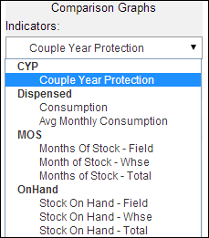

**Select Indicators**

Once user clicks the ‘Compare options’, it will give the user three options.

* + - * Years
      * Stakeholder
      * Geographical

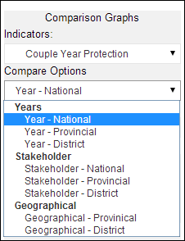

**Select Comparison options of Years, Stakeholder and Geographical location**

Once the user clicks ‘Stakeholder’, it will show the list of all stakeholders to choose one.

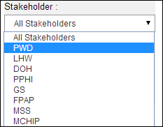

**Select the Stakeholder**

Products and Year show multiple options to select. The user can choose more than one product and year respectively. By clicking on **Time-Interval** it shows three options:

* + - * Quarter
      * Half
      * Annual

By clicking on Chart type it shows two options:

* + - * Line Chart
      * Bar Chart

**Select multiple products for comparison**

**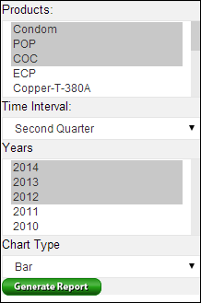**

**After selecting all values, click here to generate report.**

**Select Line or Bar Chart**

**Select one\Multiple Year for comparison**

**Select time Intervals**

#### Line Chart

**Click here to view graph in different formats such as PDF, JPG, PNG**

If the user selects line chart, it will generate graph like this:

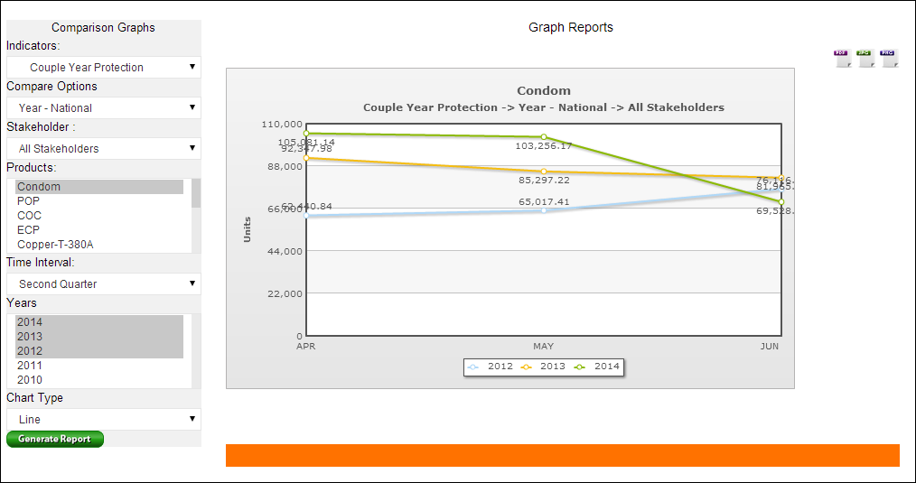

#### Bar Chart

**Click here to view graph in different formats such as PDF, JPG, PNG**

If the user selects bar chart, it will generate graph like this:

**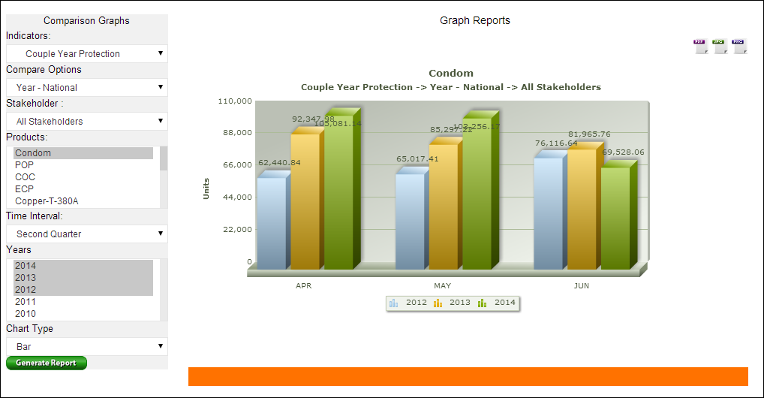**

### Simple Graphs

**Click here to view graph in different formats such as PDF, JPG, PNG**

User can also choose the same filter options to create a simple graph.

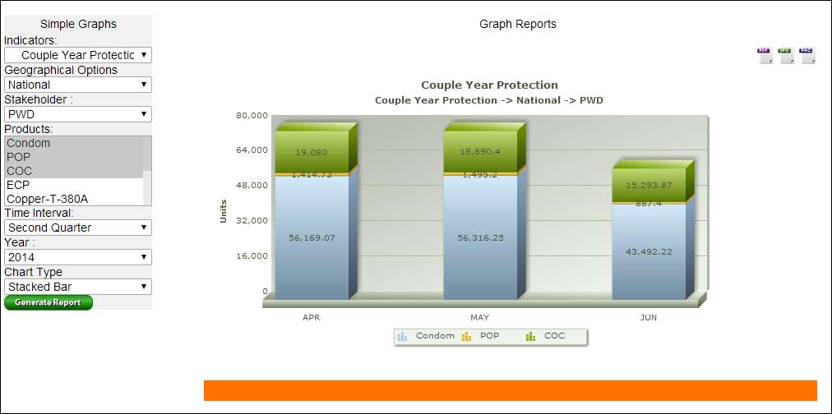

**Show the selected products data.**

|  |  |
| --- | --- |
| LMIS Explorer | **8** |
| for Contraceptive Logistics Management Information System | | |

This chapter explains the step-by-step instructions on the LMIS explorer features that can be used by the Contraceptive Logistics Management Information system’s users.

In LMIS explorer, the user can see monthly district warehouse or field store reports and data. If there is no data, a message will be shown.

**Click here to view report in different formats such as PDF and Excel**

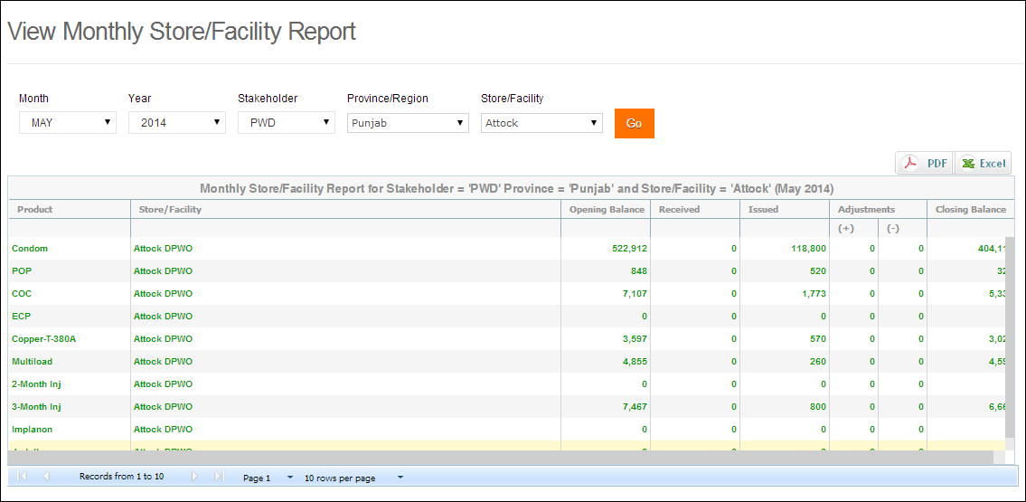

Similarly, the user can view monthly field reports and data. If there is no data for that selected field, it will show zeroes for that specific month.

|  |  |
| --- | --- |
| Guest User | **9** |
| in Contraceptive Logistics Management Information System | | |

This section explains the step-by-step instructions on the functions and features that can be used by the Contraceptive Logistics Management Information system’s Guest User.

The Contraceptive Logistics Management Information System enables you to login as a guest or anonymous user. Guest users can login into LMIS by entering username and password as ‘guest’. When a guest user enters login credentials, they can view analytical reports, maps, graphs and warehouse/district stores data report entered by stakeholder specific users for any period. However, they are not entitled to edit the data.

Logging into Guest user displays the following dashboard screen:  
 **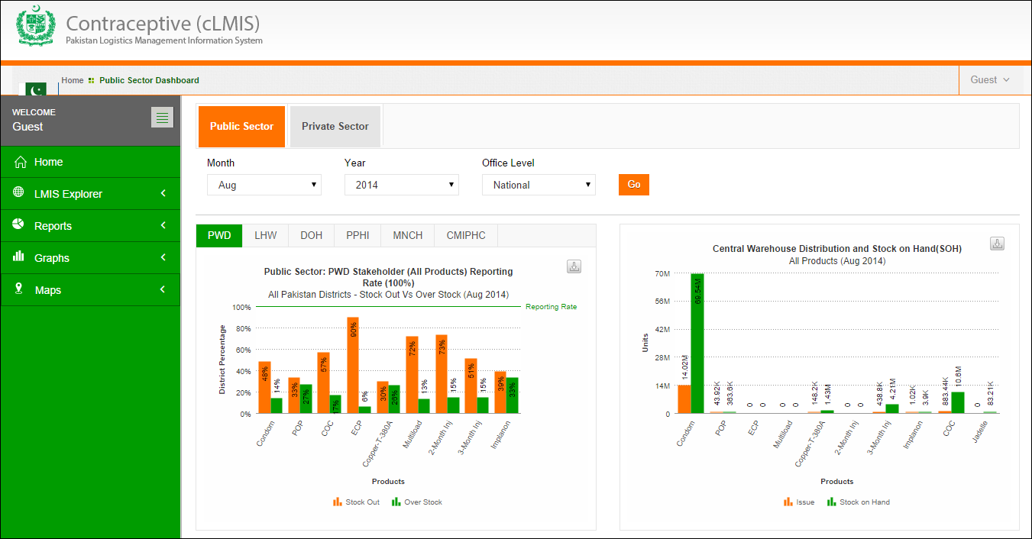**

On the left side of the dashboard screen, the guest user will see the following tabs:

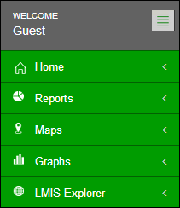

* **Guest**: User can sign out of the application by using the following link on the right side of the screen:  
  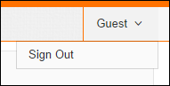
* **Dashboard**: User can view dashboards containing graphs, maps and analytical reports by using this tab.
* **Reports**: User can view analytical reports by using this tab.
* **Maps**: User can also view the analytical reports in the form of a map by using this link.
* **Graphs**: User can view simple and comparable graphs by using this link.
* **LMIS Explorer**: This link provide user to view individual warehouse / store data of a selected month.

|  |  |
| --- | --- |
| Authenticated Users - District | **10** |
| in Contraceptive Logistics Management Information  System | |

This section explains overview of the authenticated users on the district level and describes the tasks they can perform while using Logistics Management Information System for contraceptives.

In order to log on to the system, the user will be allocated a username and password. Once successfully logged in, the user will be directed to a ‘user information’ page specific to the organization. This page will contain specific information about the user’s department or organization.

In order to obtain LMIS data and reports, the user must successfully login with his/her username and password. System users are defined by relevant stakeholders and the level in the supply chain they represent. For example, Population Welfare Department users work under Provincial PWD and District Population Welfare Officer. Similarly for the Lady Health Workers’ program, the users are authorized personnel from District Program Implementation Unit (DPIU) and Provincial Program Implementation Unit (PPIU).

After a successful login, the user will be directed to stakeholder specific page. Based on the privileges assigned to the user by the system administrator, various menu items will appear on the interface homepage.

After successful login, district user will see the following menu:

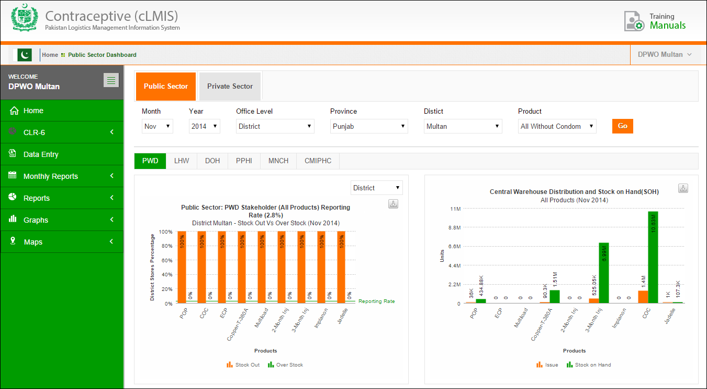

* **DPWO Multan**: Name of the User who is currently logged in.
* **Sign Out**: signs out the user to homepage of LMIS.
* **Change Password**: It allows user to change the password.
* 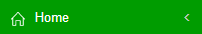: By clicking this icon, user will be reached on the dashboard page which appeared just after logging in.
* **Data Entry**: User can enter monthly reports by using this menu item.
* **Requisitions:** User can add or view requisition requests.
* **Monthly Reports**: User can view warehouse / stores reports by using this menu item.
* **Reports**: User can view pre-published analytical reports.
* **Maps**: User can view analytical reports in the form of maps.
* **Graphs**: User can view pre-published graphs.

Click **Home** to view Dashboard.

# Dashboard

Dashboard is a visual display of the most important analysis to achieve one or more objectives; consolidated and arranged on a single screen so the information can be viewed at a glance.

District user can view following dashboards by default:

* Public Sector Stakeholders
* Private Sector Stakeholders

Please refer to the **“Dashboards”** section above.

# Data Entry

Click Data Entry tab from the main menu.

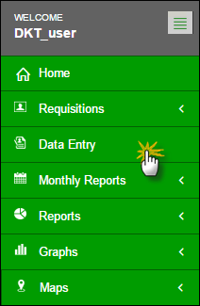

A list of consumption data entry for reporting months will be displayed as shown:

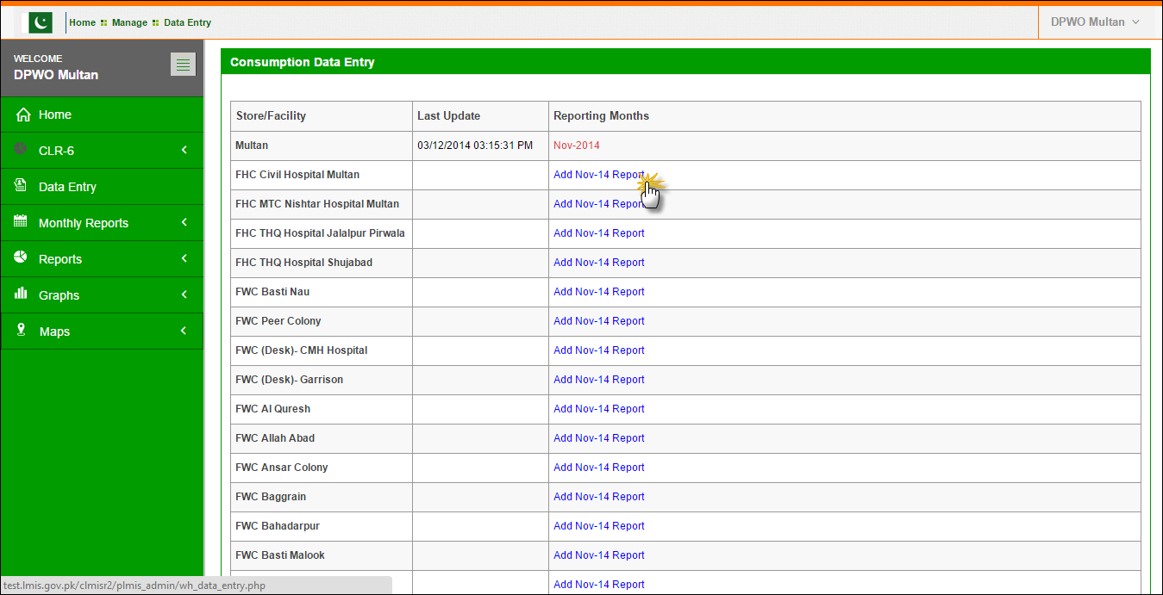

Click the Add Report option under the reporting month column. Once the user selects the Store/Facility and the month in which he/she wants to add data, a data entry screen will appear where the user can fill and save.

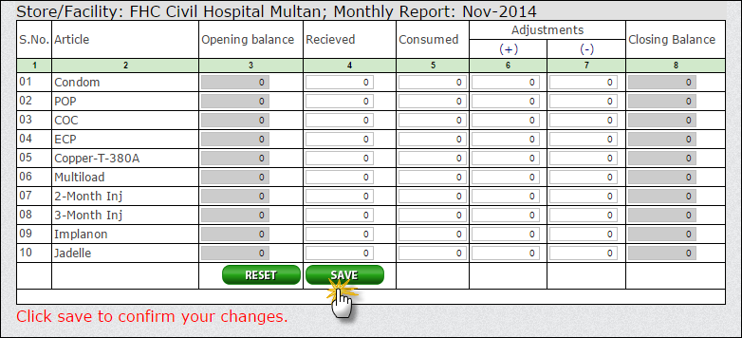

Enter the desired data within the form and click **Save.**

User can also click **Reset** to changes made.

# Requisitions (CLR-6)

Stock Requisitions (CLR-6) form is being used by EDO (H) for commodities request from CW&S. EDO (H) staff prepares this requisition form on quarterly basis in consultation with storekeeper of DPWO. This form indicates the stock status and consumption during the quarter and indicates the quantity request for each contraceptive being used in respective districts.

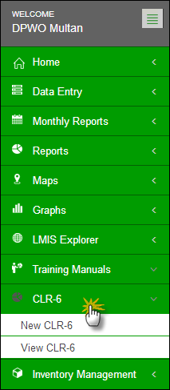

The district store users were required to fill out Requisition (CLR-6) based on the previous consumption of that district and submit to the Central Warehouse. However, in Release-2 of cLMIS, Requisition (CLR-6) is auto generated using previous consumption trends for the required quantity of products for the next quarter.

**Central Warehouse**

**Send a Requisition**

**Issue Stock against each Requisition**

### New CLR-6

New Requisition (CLR-6) auto-fills the fields by using previous consumption data of a district in a selected quarter. This sheet was previously filled by the requester. District user can create requisition and electronically submit it to the central warehouse. These requisitions will be reviewed by the management of central warehouse and stock will be issued as per stock availability and approval.

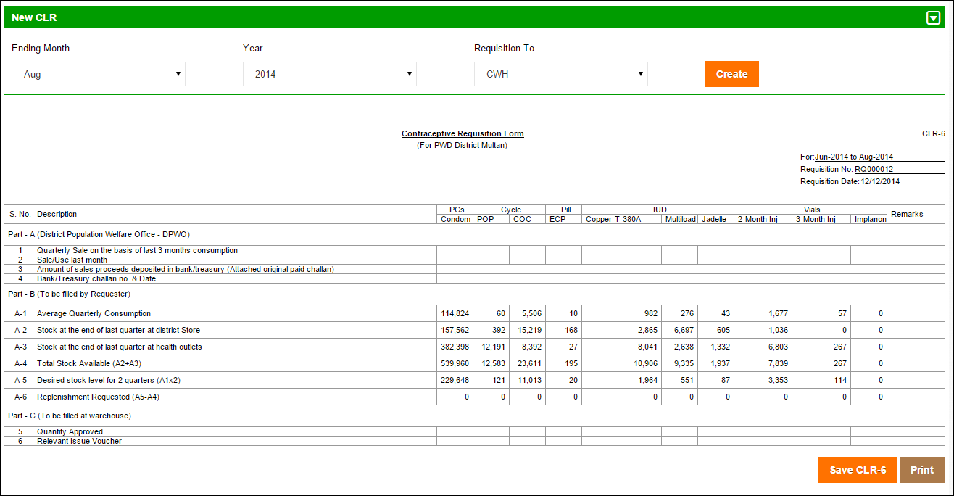

Click **Save CLR-6** or **Print.**

### View CLR-6

District users can also view a comprehensive list of requisition requests placed to the central warehouses. Details of each requisition will also be available for District users to view.

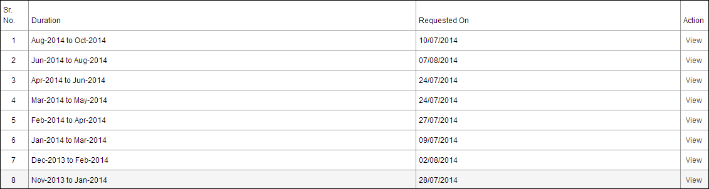

Submitted Requisition (CLR-6) can be viewed any time by the requester.

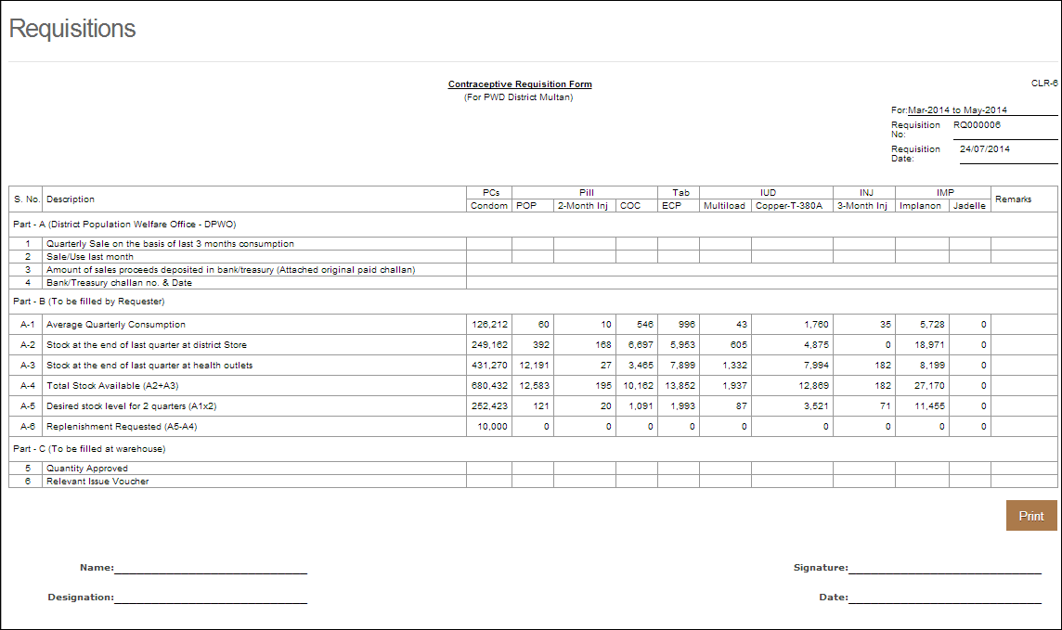

# Monthly Reports

District Users can view monthly reports of facilities / stores assigned to them as well as view reports of stores present in other districts.

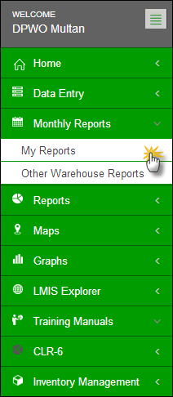

### My Reports

User can view already reported reports by clicking “My Reports”. User can select any of his/her assigned facility /store to view data of that particular month.

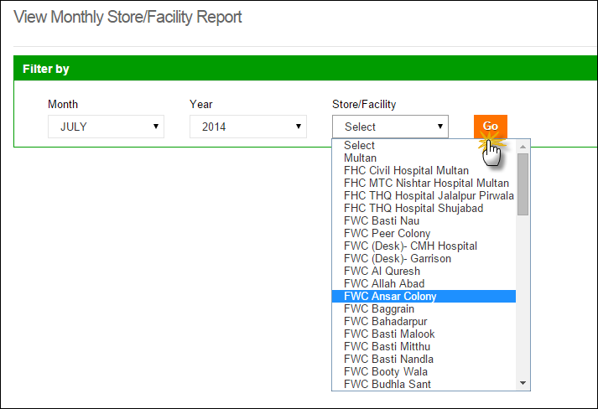

User can now view the report for the selected month.

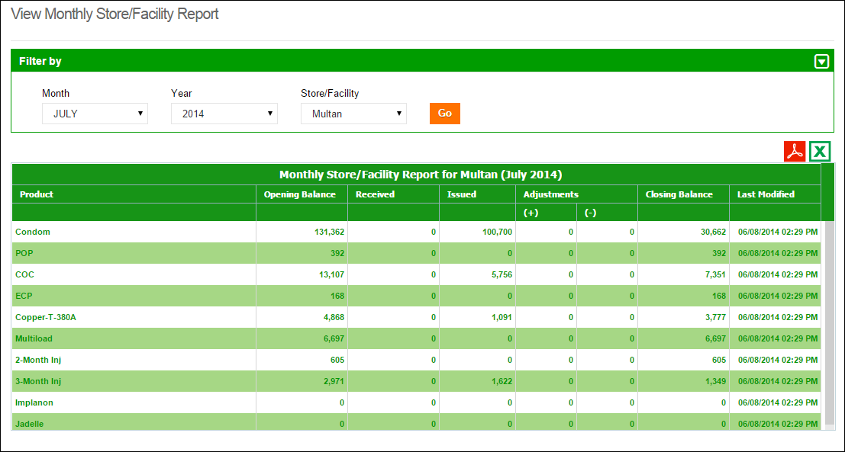

**Select Month, Year and Facility**

**Click Go**

### Other Warehouse Reports

User can also view already reported reports from other warehouses by clicking “Other Warehouse Reports”. User can select any of the stores / facilities in a district to view data of a particular month.

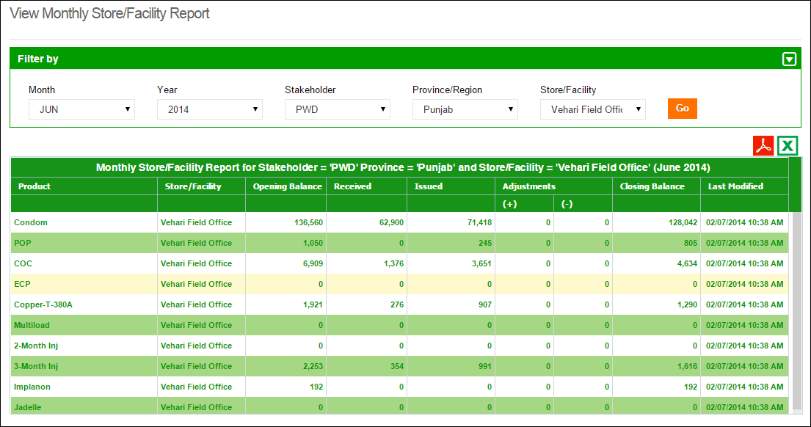

**Click Go**

**Select the Filters**

# Reports

When a user clicks the **Reports** tab, the application shows the list of all available reports. These reports include National, Provincial and District level Reports of both public and private sectors. It also includes Stakeholder Reports, Summary Reports, Field Reports and Stock Availability Reports. Quarterly and Provincial Reporting Rate has also been added in the list of available reports.

Please refer to the “Reports” chapter above.

# Maps

The cLMIS also has the capability of generating easy to interpret maps with color codes. These maps can be viewed by selecting the “Maps” tab in the menu. Once the indicator for which the map is to be viewed is selected, the user will be directed towards a page to select from various filters.

Please refer to the “Maps” chapter above.

# Graphs

The LMIS also has the capability of generating easy to interpret graphs. Simple and comparative graphs can be viewed by selecting the “Graphs” tab. Once simple or comparison graphs is selected, the user is directed towards a page from where s/he can choose various options to create graphs.

Please refer to the “Graphs” chapter above.

|  |  |
| --- | --- |
| Authenticated Users - Central | **11** |
| in Contraceptive Logistics Management Information System | |

This chapter explains overview of the authenticated users on the central level and describes the tasks they can perform while using Contraceptive Logistics Management Information System.

In order to log on to the system, central user will be allocated a username and password. Once successfully logged in, the user will be directed to a ‘user information’ page specific to the organization. This page will contain specific information about the user’s department or organization.

After a successful login, the user will be directed to stakeholder specific page. Based on the privileges assigned to the user by the system administrator (in this case, the user has privileges of a central user), various menu items will appear on the interface homepage.

After successful login, central user will see the following menu:

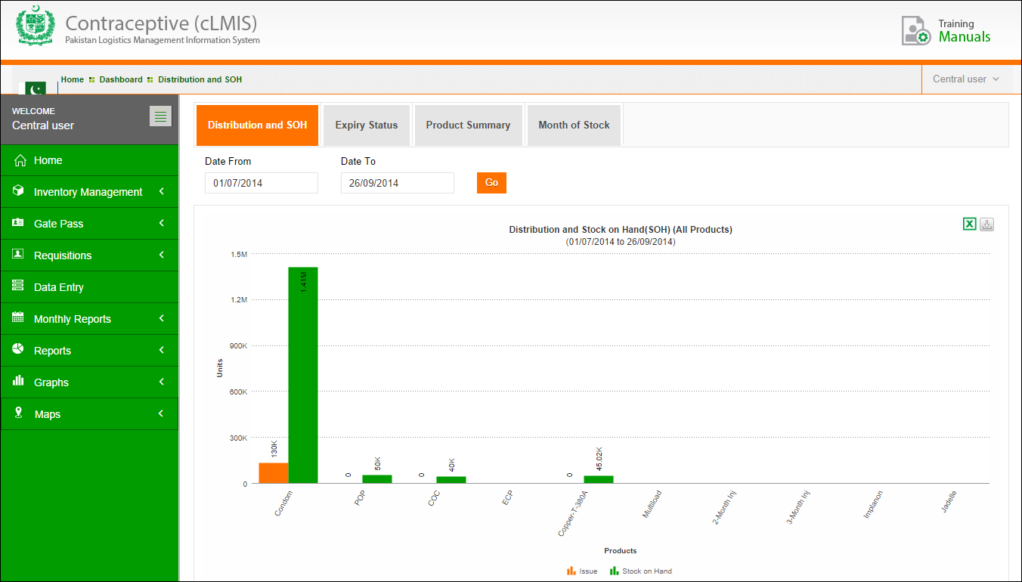

* **Central user**: Name of the User who is currently logged in.
* **Sign Out**: signs out the user to homepage of LMIS.
* **Change Password**: It allows user to change the password.
* **:** By clicking this icon, user will view the available dashboards.
* **Data Entry**: User can enter monthly reports by using this menu item.
* **Monthly Reports**: User can view his and other warehouse / stores reports by using this menu item.
* **Reports**: User can view pre-published analytical reports.
* **Maps**: User can view analytical reports in the form of maps.
* **Graphs**: User can view pre-published graphs.
* **LMIS Explorer**: User can view monthly warehouse report.
* **Requisitions:** User can view, approve or decline requisition requests.
* **Inventory Management:** User can manage the inventory of the district facility / store.

# Dashboard

Dashboard is a visual display of the most important information needed to achieve one or more objectives; consolidated and arranged on a single screen so the information can be monitored at a glance.

Central user can view following dashboards by default:

* Distribution and Stock on Hand (SOH)
* Expiry Status
* Product Summary
* Month of Stock

## Distribution and Stock on Hand (SOH)

When a central user logs in, user will view stock distribution and stock on hand (SOH) in a graphical manner for public sector stakeholders. The bar graph will show the comparison between the issued stock and the stock on hand (SOH) for all products.

Select **Date From** and **Date To** from the available filters and click **GO.**

**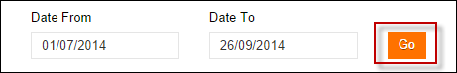**

A bar graph for stock distribution and stock on hand comparison for all products will be displayed.

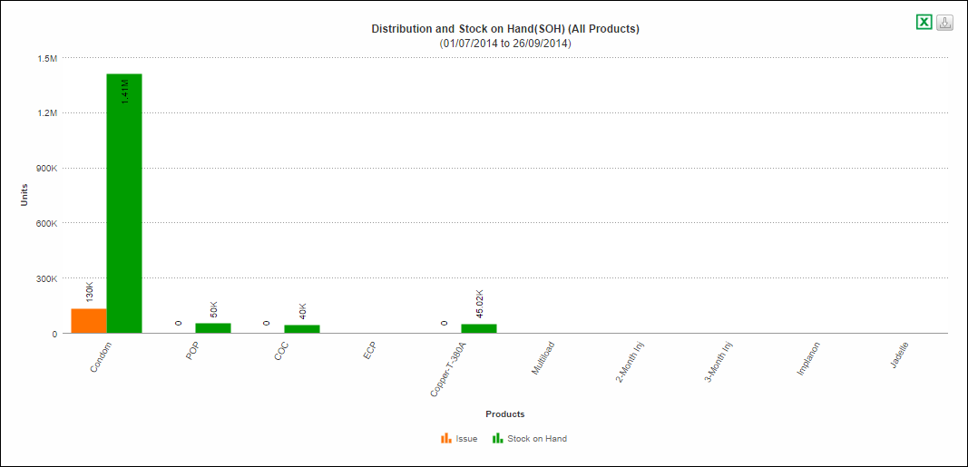

Users can also export charts in CSV, JPEG, PNG, PDF and SVG format.

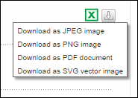

## Expiry Status

User can click the Expiry Status dashboard to view the expiry status of the available stock in the form of a pie-graph for public sector stakeholders.

Select **Product** from the available filters and click **GO.**

**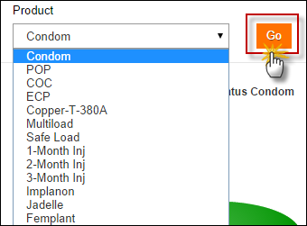**

A pie-graph for stock expiry status for the selected product will be displayed.

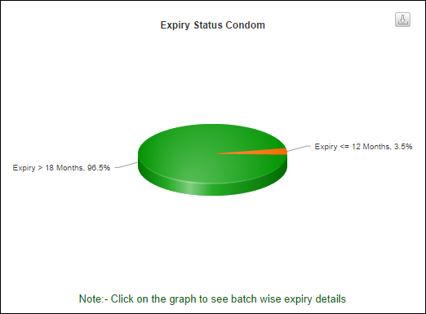

Click on the pie-graph distribution to view details for the batches expiry status.

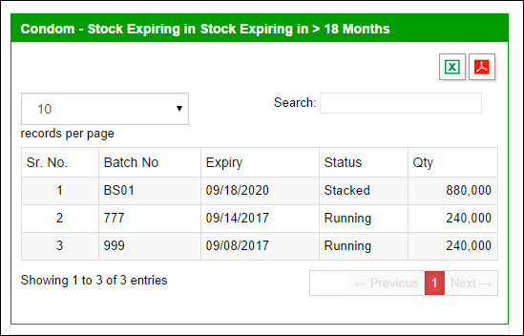

Users can also export charts in CSV, JPEG, PNG, PDF and SVG format.

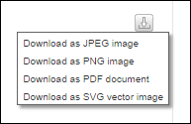

## Product Summary

Once user clicks the product summary dashboard, user will view the stock summary report for public sector stakeholders.

Select **Date From** and **Date To** from the available filters and click **GO.**

****

A report for the summary of stock will be displayed which includes:

* Opening Quantity
* Received Quantity
* Issued Quantity
* Closing Quantity

A stock summary report will be generated for the selected time period. Users can also export charts in PDF and CSV format.

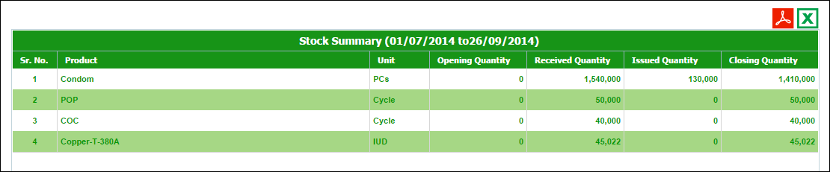

## Month of Stock

Once user clicks the month of stock dashboard, user will view the MOS for the selected period of time in the form of a bar graph for public sector stakeholders.

Select **Year** and **Quarter** from the available filters and click **GO.**

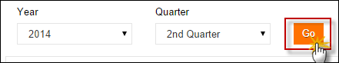

A bar graph for month of stock for all products will be displayed.

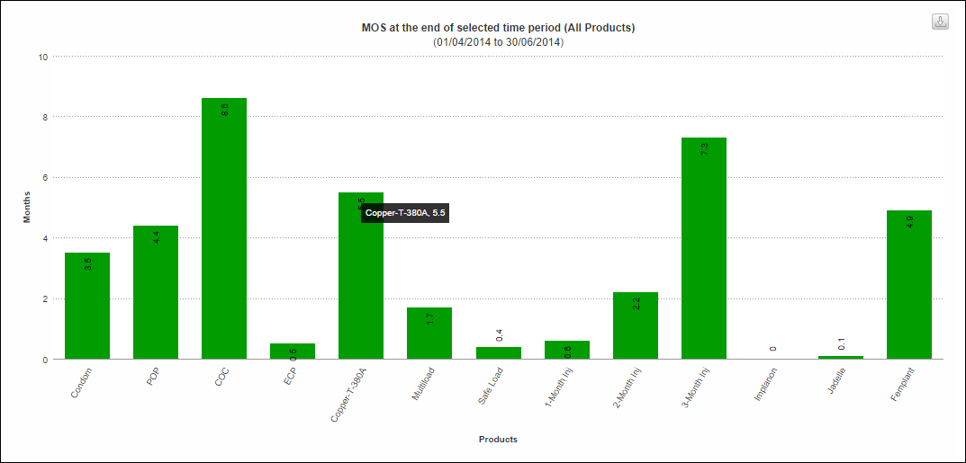

Users can also export charts in CSV, JPEG, PNG, PDF and SVG format.



# Requisitions

Requisition form is used by EDO (H) for commodities request from CW&S. EDO (H) staff prepares this requisition form on quarterly basis in consultation with storekeeper of DPWO. This form indicates the stock status and consumption during the quarter and indicates the quantity request for each contraceptive being used in respective districts.

Central warehouses can manage requisition requests placed by the district stores or facilities. Central users can approve these requisition requests.

### Requisition Requests (CLR-6)

The district store places a Requisition Request (New CLR-6) based on the previous consumption of that district and submits to the Central Warehouse. This Requisition Request (CLR-6) is auto generated using previous consumption trends for the required quantity of products for the next quarter.

**Central Warehouse**

Issue Stock against each Requisition

Send a Requisition

District users can create requisition requests and electronically submit it to the central warehouse. These requisitions will be reviewed by the management of central warehouse and stock will be issued as per stock availability and approval.

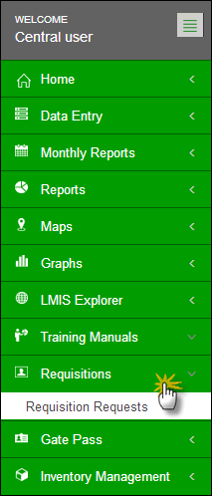

Central and provincial stores are able to manage requisition requests by district stores. System will provide options to view detail Requisition (CLR-6), stock issue voucher against any requisition and approve.

Click **Requisition Requests** under the Requisition tab.

To find a requisition request placed by district users, you can specify the following:

* **Province:** select a province.
* **District:** select a district from the list.
* **Stakeholder:** select the required stakeholder
* **Issue Ref.**: To search using the Issue Ref, select this option and then specify the Issue Ref in the adjacent text box.
* **Batch No.:** To search using the Batch No., select this option and then specify the Batch No. in the adjacent text box.

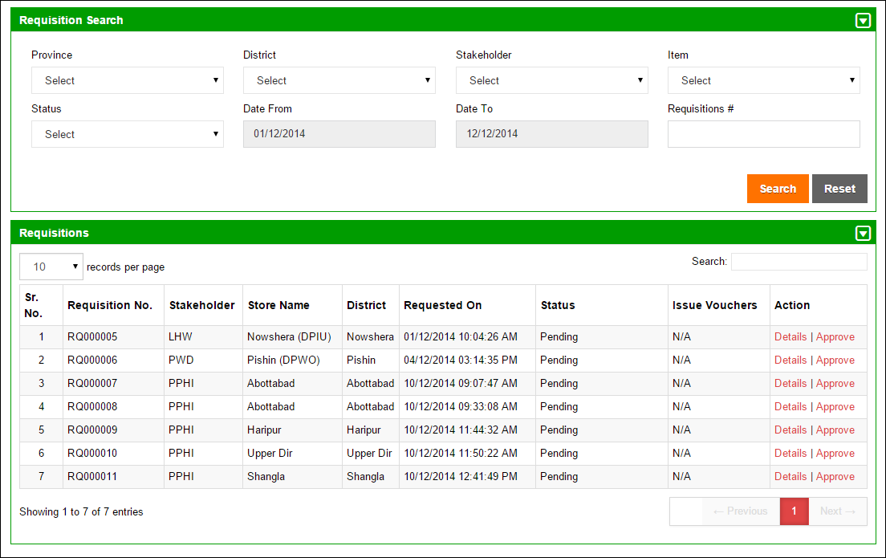

**Search a Requisition Request**

Central user can select the following actions to perform:

**Details:** to view the details of the requisition request placed by the district user.

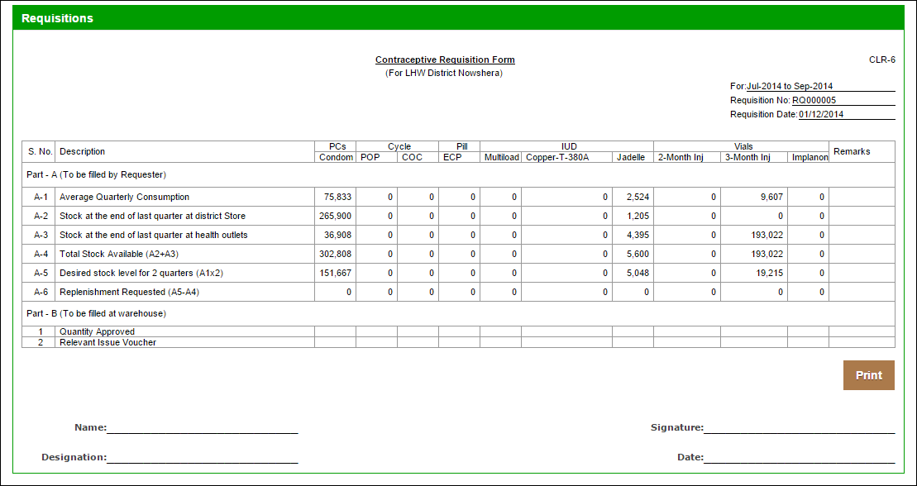

**Approve:** to approve or decline the requisition request placed by the district user.

**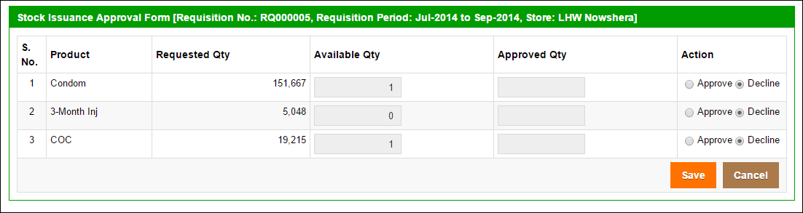**

# Inventory Management

Inventory Management is a component of supply chain management and supervises the flow of goods from suppliers to warehouses and from these facilities to the districts and ultimately to the point of sale. One of the key functions of inventory management is to keep a detailed record of each new or returned product as it enters or leaves a warehouse or the point of sale.

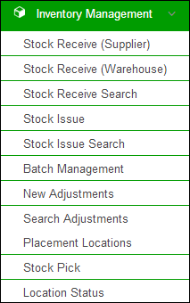

Inventory Management feature enables the Store User to manage the inventory for the central warehouse. The Store User can perform the following:

* **Stock Receive from Supplier**: Central users can receive stock directly from supplier.
* **Stock Receive from Warehouse**: Central users can also receive stock from other warehouses.
* **Stock Receive Search**: Central users can search the received stock from other warehouses or suppliers.
* **Stock Issue to Warehouses**: The stock is issued to other warehouses and stores on demand.
* **Stock Issue Search**: Central users can search the issued stock to other warehouses.
* **Batch Management**: When stock is received, the user marks the batches with latest expiry date as ‘Running’, so that this stock can be issued first.
* **Stock Adjustments**: If stock is lost or recovered, user can add adjustments in cLMIS.
* **Search Adjustments**: User can search the added adjustments for a selected duration.
* **Manage Locations**: User can also manage the location of stock within the warehouse.
* **Location Status**: User can check the stock available at a particular location in the warehouse and transfer it to another location.
* **Stock Pick**: User can select Issue No. to pick a particular product from the voucher list.

### Stock Receive (Supplier)

Users at the central level can receive stock directly from the supplier. Users can also add information such as Funding Source, Product, Manufacturer and batch information i.e. Batch No, Expiry Date and Quantity of the required product.

Specify the following information:

* **Receipt No**: is an automatically generated number for identifying the receive transaction.
* **Ref No**: specify the receive reference.
* **Received Date:** Click on Receive date to expand the date picker tool and select the date.
* **Receive From**: Select the supplier for the product.
* **Product**: select the product from the list.
* **Manufacturer**: select or add the manufacturer for the selected product.
* **Batch No:** specify the batch number for the product.
* **Expiry Date:** Click on Expiry date to expand the date picker tool, or type-in the required date using format dd/mm/yyyy.
* **Quantity:** Add the received quantity for the selected product.

Click **Save Entry** to add the entry in the receive list. The entry moves to the Receive List. You can add new entries, as required. All of the entries will be displayed in the Receive List.

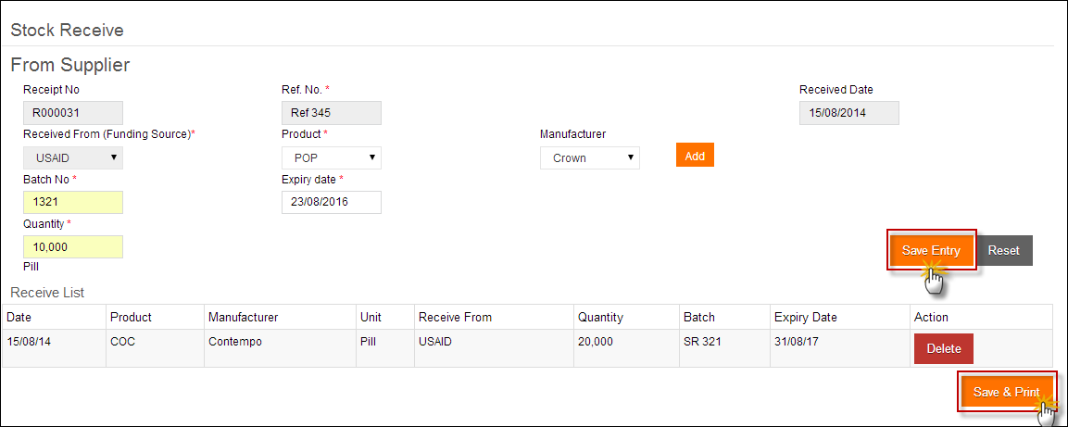

User can also click **Save & Print** to save the complete receive list. Once user saves the receive list, The Receive order is saved and a Stock Receive Voucher is created.

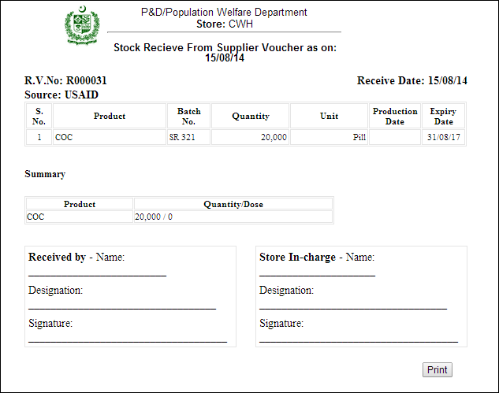

### Stock Receive (Warehouse)

Central warehouse users can receive the stock being issued by other warehouses such as at the provincial or district level. Storekeepers will be able to receive products against the issue voucher number provided by the issuing authority.

Add **Issue Number** to search for the required entry in database. The required issued entry will be displayed.

Review the issued product’s details. The table includes:

* **Product**: displays the product name.
* **Batch:** displays the batch number for the product.
* **Quantity:** displays the issued quantity.
* **Adjusted Quantity:** if the received quantity is different than the issued quantity, you can enter the adjusted quantity in this text box.
* **Adjustment:** specify the adjustment type.
* **Receive Reference**: specify the receive reference.
* **Receive Date:** Click on Receive date to expand the date picker tool and specify the received date.
* Check the  icon in the end of the row and then click **Save & Print**.

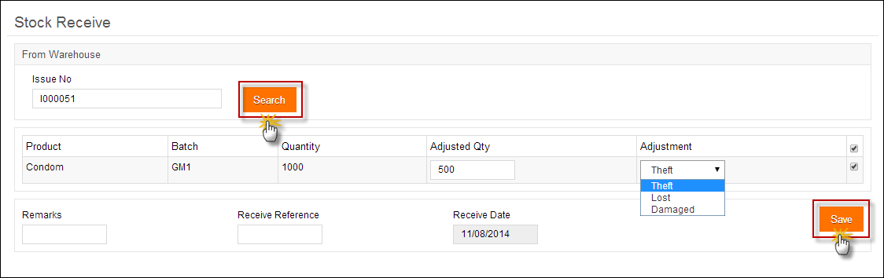

### Stock Receive Search

User can search received stock by Receive No, Receive Ref or Batch No. Users can also select Warehouse Supplier and Product to search a particular stock.

To search for a receive entry, specify the following filters:

* **Search By**: Specify the unique identifier you want to search by. The options include:
* **Receive No**: if you know the receive number, select this option and specify the receive No. in the adjacent text box.
* **Receive Ref**: To search using the Receive Ref, select this option and then specify the Receive Ref in the adjacent text box.
* **Batch No.:** To search using the Batch No., select this option and then specify the Batch No in the adjacent text box.
* **Warehouse Supplier:** select the warehouse supplier. This is optional field.
* **Product:** select the required product from the list.
* **Date From, Date To:** Click on date to expand the date picker tool and select dates.  
    
  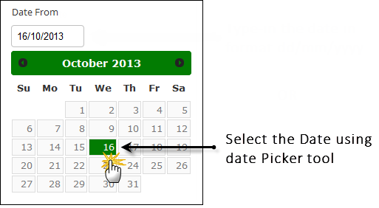

Click **Search**.

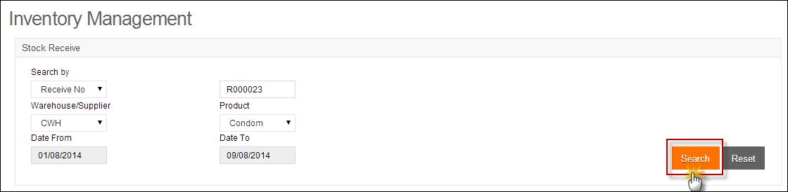  
The required entries are displayed in the Receive Search list.

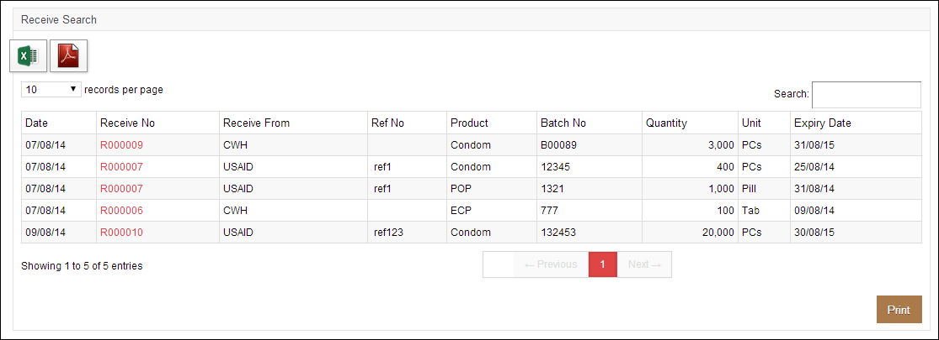

### Stock Issue

Central users can issue stock using this option. At National level, the stock issue is based on the districts requisition (CLR-6). Provincial and district storekeepers can also issue the stock back to the respective upper level store if required.

To issue stock, specify the following filters:

* **Date:** Click on date to expand the date picker tool and add a date.
* **Stakeholder:** Select stakeholder from the list**.**
* **Office:** Select office from the drop down list.
* **Store:** Select the store from the list.
* **Product:** Select the product from the list.
* **Batch No:** Select batch no. for the selected product.
* **Quantity:** Add quantity from the quantity of the product available.
* **Expiry Date:** Click on date to expand the date picker tool and add a date.

Click **Add Issue.**

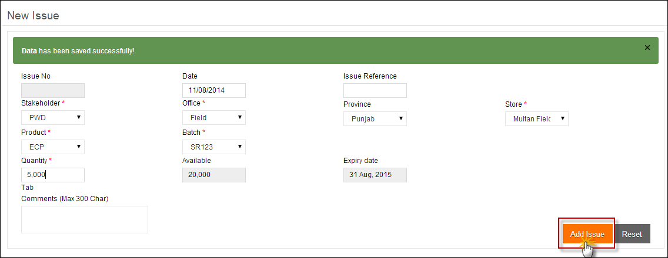

The newly added entry is displayed in the Issue list. Click **Save.**

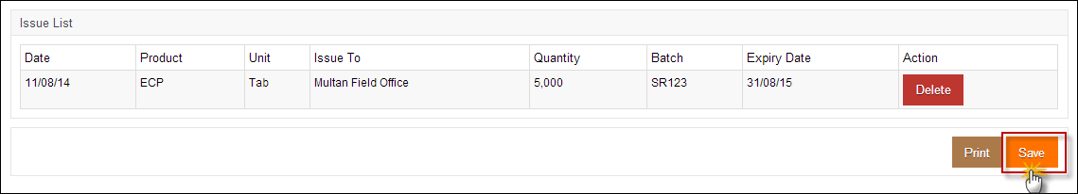

### Stock Issue Search

Central users can also search the issued stock by Issue No, Issue Ref or Batch No. Users can also select Warehouse Supplier and Product to search a particular stock. System provides an option to print filtered search as well as individual transaction. Users can also print stock issue summary as well as detailed list based on product and location.

To search for an issued entry, specify the following filters:

* **Search By**: Specify the unique identifier you want to search by. The options include:
* **Issue No**: if you know the issue number, select this option and specify the issue No. in the adjacent text box.
* **Issue Ref**: To search using the Issue Ref, select this option and then specify the Issue Ref in the adjacent text box.
* **Batch No.:** To search using the Batch No., select this option and then specify the Batch No in the adjacent text box.
* **Warehouse / Supplier:** select the warehouse / supplier. This is optional field.
* **Product:** select the required product from the list.
* **Date From, Date To:** Click on date to expand the date picker tool.   
    
  

Click **Search**.

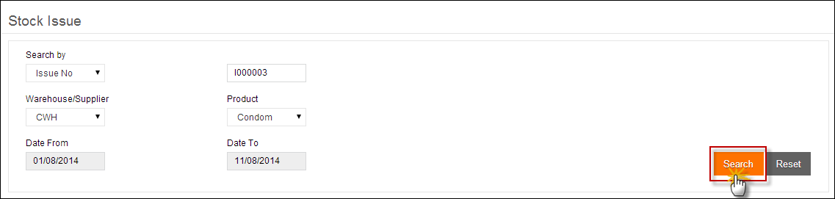

The specified issued stock will appear in the Issue Search list.

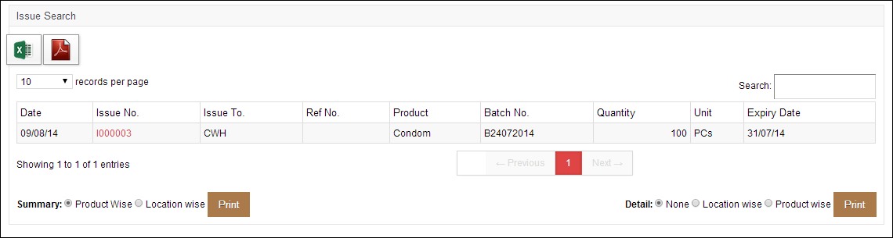

### Batch Management

Once the stock is received in warehouse, each package is identified by its Batch Number and Expiry Date. Each batch is sorted by its expiry date by the rule of “First Expiry First Out”. When batches of stock are added to cLMIS, the account user usually assigns the batches with latest expiry date as ‘Running’. The running batches are issued first. cLMIS provides a section for batch management of each product. Each batch will have a status i.e. Running, Stacked and Finished. Central users will be able to change the status from Running to Stacked as desired.

Stock can be issued only if their batch status is set to Running by the system. One or more batches can be set to running depending on the quantity and expiry date of the product.

System provides a summary of batches of each product with a total quantity.

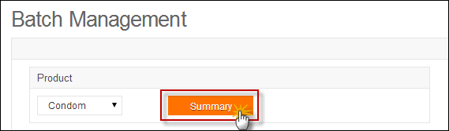

Batch Management summary for the stock will be displayed.

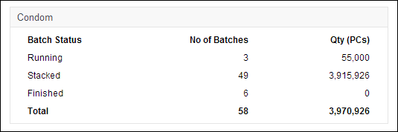

In order to mark the status of the batch, you can specify search criteria to search for the required batch as follows:

* **Product:** select the required product from the list.
* **Status:** specify the status of the batch that you are searching for.
* **Running:** Only the batches with the status “Running” can be issued.
* **Stacked:** Stacked batches represent that they are stacked in the warehouse and cannot be issued.
* **Finished:** batches have finished.
* **Total:** total number of running and stacked batches.
* **Batch No:** Optionally, specify the Batch No of the required batch.
* **Ref. No:** Optionally, specify the Ref. No. of the required batch.

Click **Search.**

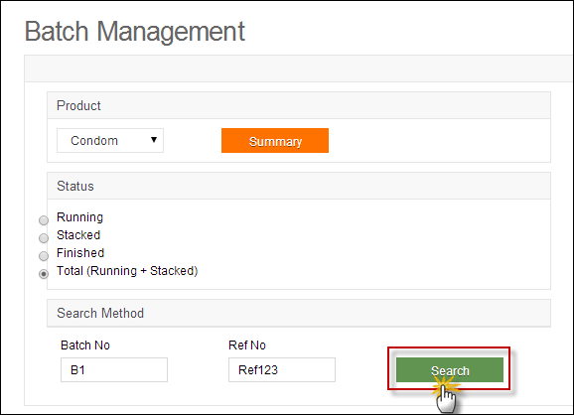

The Search results are displayed in a table.

**Click the button to make the Batch either Running or Stacked.**

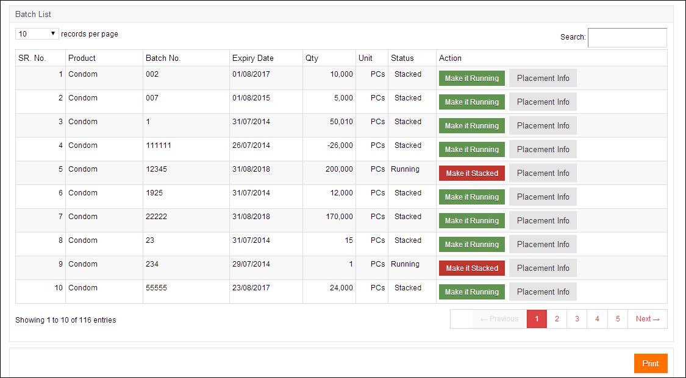

**Click the button to display Placement Info**

You can review the batch status and change it by clicking the button adjacent to it.

|  |  |
| --- | --- |
| C:\Users\isbah.zulfiqar\Desktop\1382615592_file_edit.png | Remember that in order to issue batches, you have to first set the status to ‘Running’. |

Click **Print.**  
The Batch management form is saved and printed.

### New Adjustments

Every now and then, users want to update the number of items in stock manually. In case of lost and damaged items or you have received less inventory than expected, you can add stock adjustments for managing you inventory.

Central users can add adjustments of stock as theft, lost, lost recovered, expired or damaged.

To add new Adjustments, specify the following criteria:

* **Adjustment Date:** Click on adjustment date to expand the date picker tool and select date.
* **Ref. No.:** Optionally, specify the Ref. No. of the batch.
* **Product:** select the product from the list.
* **Batch No:** Specify the Batch No of the batch.
* **Adjustment Type:** specify the adjustment type.
* **Quantity:** Specify the quantity of the product.
* **Comment**: Add comments, if any.

Click **Save.**

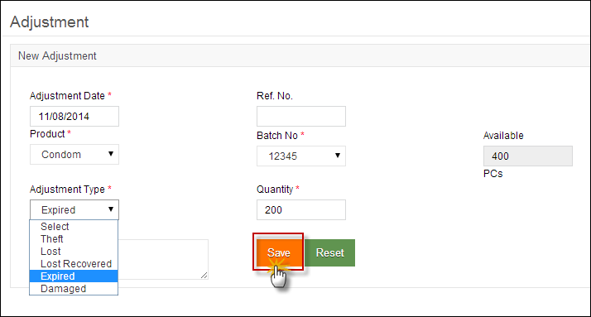

**Specify Adjustment Details.**

### Search Adjustments

Central users can also search adjustments to stock by adjustment type and product. System provides an option to print filtered search and individual transaction.

To search for Adjustments, specify the search criteria:

* **Adjustment No.:** is an automatically generated unique identifier for the adjustment.
* **Adjustment Type:** specify the adjustment type.
* **Product:** select the product from the list.
* **Date From, Date To:** Click on date to expand the date picker tool and select the dates.

Click **Search.**

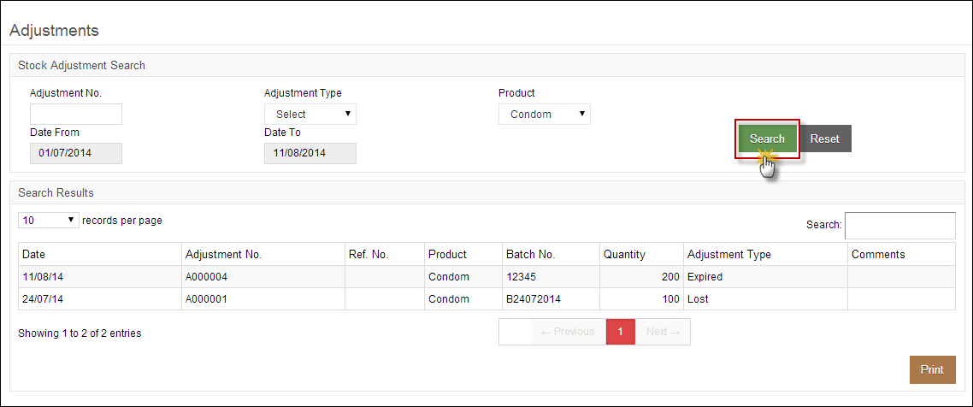

### Placement Locations

Central users can manage placement locations for the stock within the main warehouse by adding location Area, Row, Rack, Rack Type, Pallet as well as Level.

To manage locations for the stock within the warehouse, select the following filters:

* **Area:** Select the area for the location.
* **Row:** Select the row for the location of stock.
* **Rack:** Select the rack for the stock location.
* **Rack Type:** Select the rack type as Single or Double.
* **Pallet:** Select the pallet for stock location.
* **Level:** Select the level for the location for the list.

Click **Save Entry.**

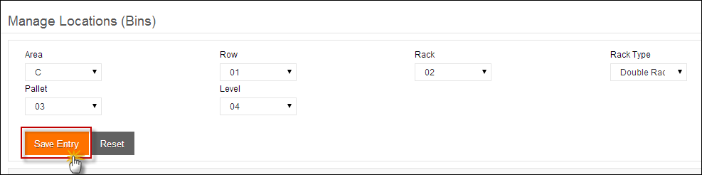

Location list of stock placement locations is available. User can also search for a stock location from the list.

**Search locations for stock.**

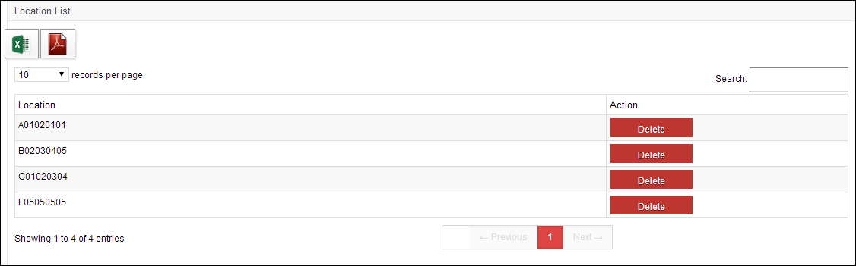

### Stock Pick

Central users also have an option to issue stock to other warehouses, provincial stores / facilities as well as field offices. Once a central user issues stock to a district, it is placed at a location within the warehouse. User can manage placement location of the stock from **Location Status** (see the next section).

|  |  |
| --- | --- |
| C:\Users\isbah.zulfiqar\Desktop\1382615592_file_edit.png | Remember that in order to issue and pick batches, you have to first set the status to ‘Running’. |

From the **Issue Voucher List**, select **Issue No.** to pick a stock of any particular product.

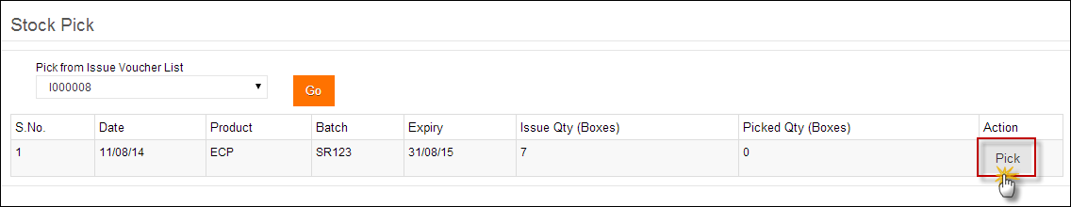

Click **Pick.** A new screen is displayed.

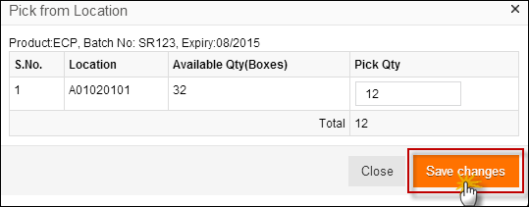

### Location Status

Central users can select **Area** and **Level** to show a particular location for allocating the stock.

Click **Show Status.** The placement location will appear.

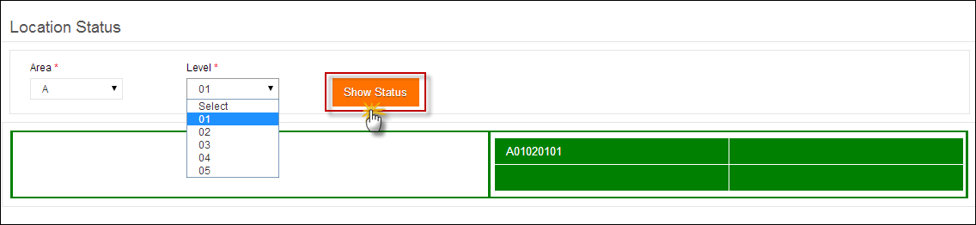

**Click the displayed location.**

When user clicks the placement location, the details of the product present at that location will appear.

In order to transfer the stock available at this location,

* Add quantity of boxes under **Transfer.** (The quantity of boxes to transfer should be less than or equal to the available number of boxes.
* Select the location to transfer stock.

**Click to add more stock at this location.**

* Click **Save.**

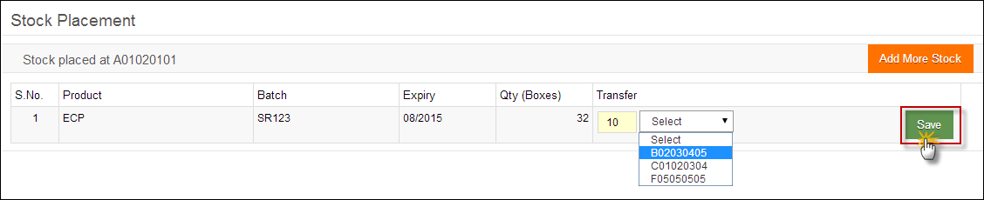

To add more stock to this location, click **Add More Stock.** A complete list of received stock will be displayed.

**Add boxes of stock to allocate**

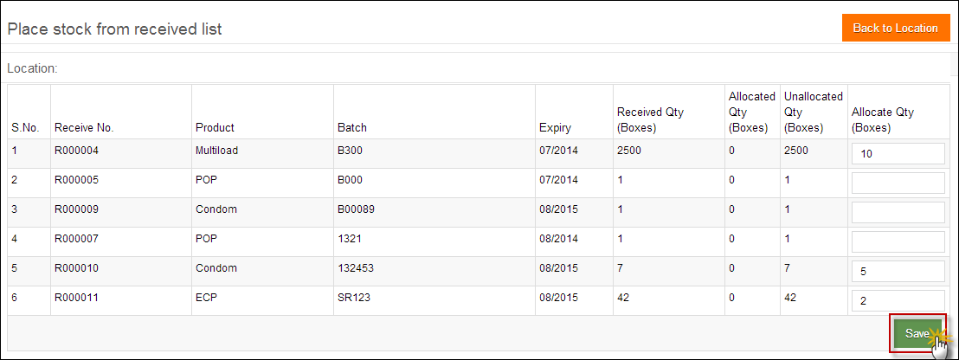

# Gate Pass

Once a stock has been picked to be transferred to another location, a new gate pass will be created. To create a new gate pass, select the Issue No. of the products to be picked along-with the vehicle and vehicle type. User will also add the quantity to be picked from the issued quantity of the product.

Select **Gate Pass** from the main menu to issue a new gate pass or view a list of gate passes.

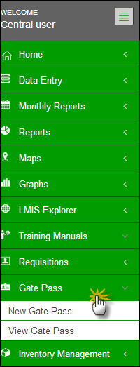

### New Gate Pass

Click **New Gate Pass** under the Gate Pass tab.

To issue a new gate pass, you can specify the following:

* **Date From, Date To:** Click on date to expand the date picker tool and select dates.
* **Vehicle Type:** select a vehicle type.
* **Vehicle:** select a vehicle from the list or check other.
* **Issue No.**: select one or multiple issue numbers from the shown list.
* **Date:** Click on date to expand the date picker tool and select date.

The issued products will be displayed in the list. Add the quantity to create gate pass from the issued quantity and click **Save.**

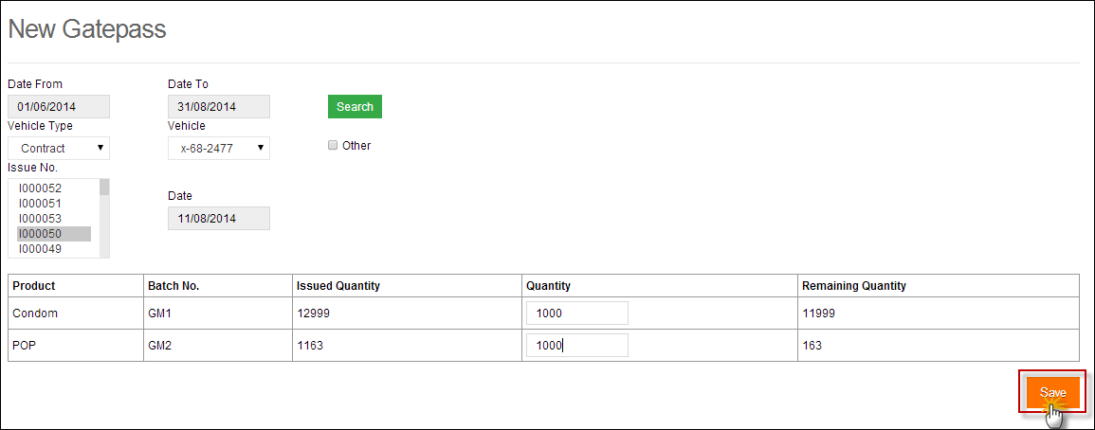

**Select the filters to create a new gate pass.**

### View Gate Pass

Click **View Gate Pass** under the Gate Pass tab.

To view the list of issued gate pass, you can specify the following:

* **Date From, Date To:** Click on date to expand the date picker tool and select dates.
* **Vehicle Type:** select a vehicle type.
* **Vehicle:** select a vehicle from the list or check other.

Click **Go.** The list of gate passes will be displayed.

**Click Go**

**Search a gate pass from the displayed list**

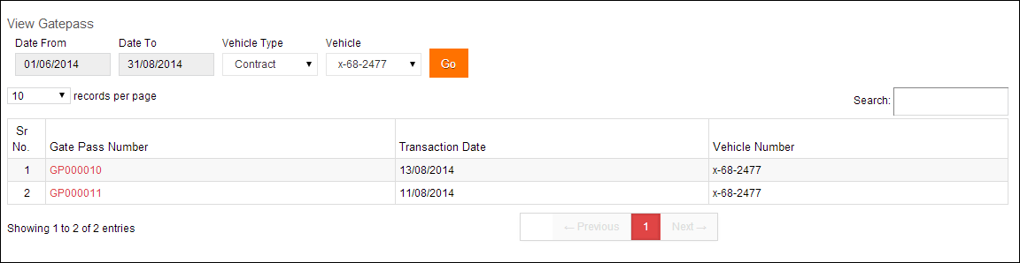

# Reports

When a user clicks the **Reports** tab, the application shows the list of all available reports. These reports include National, Provincial and District level Reports of both public and private sectors. It also includes Stakeholder Reports, Summary Reports, Field Reports and Stock Availability Reports. Quarterly and Provincial Reporting Rate has also been added in the list of available reports.

Please refer to the “Reports” chapter above.

# Maps

The cLMIS also has the capability of generating easy to interpret maps with color codes. These maps can be viewed by selecting the “Maps” tab in the menu. Once the indicator for which the map is to be viewed is selected, the user will be directed towards a page to select from various filters.

Please refer to the “Maps” chapter above.

# Graphs

The LMIS also has the capability of generating easy to interpret graphs. Simple and comparative graphs can be viewed by selecting the “Graphs” tab. Once simple or comparison graphs is selected, the user is directed towards a page from where s/he can choose various options to create graphs.

Please refer to the “Graphs” chapter above.

